Final Exam/Form C Name: ______________________
Directions: Show all work. Section: _____________________

- Which one of the following equations describes a line passing through the origin and perpendicular to ?

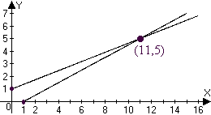
- The graph below shows the solution to which one of the following systems of equations?

- Which one of the following gives both solutions to the equation ?

- Which one of the following represents the solution to the inequality ?

- If , then

- Which equation represents a circle in the x-y plane of radius 8 and center at ?

- Which one of the following exponential functions best fits the table of values?
 |  | 0 |  | 10 | 20
 |  | 100 |  | 112.36 | 126.25

- Which one of the following rational functions has vertical asymptotes along the lines and ?

- Which one of the following gives the first 6 terms of the sequence defined recursively by

- Observe that satisfies the horizontal line test. Which one of the following is a table of values for the inverse function, ?

- Find coordinates for the vertex and intercepts of the parabola .
- Write an equation for the line with slope and x-intercept .

- Given that a line has slope and y-intercept , complete the table:
 | 0 | 8 | 16 | 24

- The kilowatt-hour (kWh) is a unit of energy. Information about the energy used by 3-bedroom house (measured in kWh) per time (in hours) over the course of a day is tabulated below. Is the energy being used at a nearly linear rate? If not, why not? If so, approximate to two digits the rate of energy consumption (in kWh per hour.)
Time (in hours) | 0 | 6 | 18 | 24
Kilowatt-hours used (kWh) | 0.00 | 11.28 | 33.89 | 45.12

- Find an equation for the line perpendicular to and passing through the midpoint of the line segment joining and .
- The cheetah is listed as an endangered species. The U.S. Fish and Wildlife Service estimates that worldwide population of wild cheetahs has declined from about 100,000 in 1900 to about 12,000 in the year 2000, all of which live in Africa except for a small population of about 200 that live in Iran. If we assume that the rate of decline of the cheetah population was linear over this time, then find a formula for the population of the worldwide cheetah population t years since 1900.
- Solve the system by back substitution:

- Solve the system using Gaussian elimination on an augmented matrix.

- A coin collection consists of pennies, nickels and dimes. There are 40 coins. The total value of the coins $2.53. The number of dimes is 1 more than twice the number of pennies. Set up and solve a system of equations to find how many of each type of coin there are.

- Find an equation for the parabola with a vertex at the origin and passing within a distance of 0.01 near .

- Simplify exact values for both solutions to the equation .

- Simplify exact values for the coordinates of the intercepts and the vertex of the parabola . Sketch a graph showing these features.
- A projectile is shot upwards so that its height (in feet) after t seconds is given by . At what times will it be at a height of 11 feet?
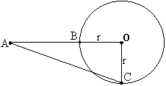
- In the diagram at right, is a right triangle with right angle at the origin, O. Solve for r if AC = 53 and AB = 17.
- In the diagram at right, express the value of AB in terms of r if AC = 4r.
- Use the quadratic formula to solve the following equation for y in terms of b: .
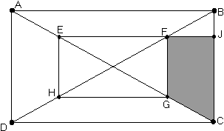
- As shown in the diagram at right, the vertices of rectangle EFGH lie on the diagonals of rectangle ABCD. If , and , find the area of trapezoid FJCG.
- Find the domain and range of the function , partially graphed below: 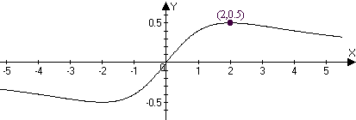

- Make a table of values with at least 5 coordinate pairs, sketch a graph and state the domain and range of the function .

- Simplify .
- Find two real solutions to the equation: .
- Find both solutions to the equation: .
- Solve for y: .
- Find n so that .
Questions 35 and 36 relate to the following table showing population data for men between 15 and 49 years old in India. Population numbers are in thousands.
- Use a linear model to fit the data for years 1995 and 1997. What population does this linear model predict for 2000?
- Use an exponential model to fit the data for years 1995 and 1997. What population does the exponential model predict for 2000?
- What is the coefficient of in the expansion of the product ?
- Write the product as a single fraction in lowest terms: .
- Find x so that .
- Solve for c in the equation . Assume that .
- Winifred borrowed $100,000 at 8% annual interest for a house. If the interest is compounded monthly and she pays $800 per month towards the loan, how much does she owe after 2 monthly payments?
- Find the 35th term in the arithmetic sequence:
- Evaluate the series algebraically: .

- Solve for y: .

- Find the center, vertices, foci and asymptotes for the hyperbola given by the equation and sketch a graph showing these features.

- Determine the exact coordinates of the points where the line intersects the ellipse in simplified radical form.

- Find an equation for the ellipse whose graph is shown. 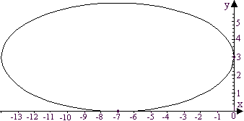
- Use a calculator to approximate the solution to a system in variables with the following augmented matrix:
- Approximate to the nearest hundredth the coordinates of the foci of the hyperbola described by

- Use a calculator to help make a graph of the function for . Approximate maximum and minimum values for the function on this interval to the nearest thousandth.
- There are three real solutions to the equation . Use a calculator to find 4-digit approximations for all three.
United States’ Petroleum consumption C (in millions of barrels per day) during the 1970’s can be modeled by the cubic function of t, the number of years since 1970: . Questions 52 and 53 refer to this model.

- Graph the function to describe daily petroleum consumption from 1970 to 1980.
- According to the model, in what year was daily petroleum consumption least? In what year was petroleum consumption greatest?
- Given, use a calculator to approximate to the nearest hundredth. For what value of r is ?

- Use a calculator to approximate correct to the nearest hundredth.

Solutions For Final Exam/Form C.
- d | - b | - b | - d | - b | - f | - b | - a | - c | - d
- The vertex of is at . Intercepts are at and .
- .

- For the first 6 hours, the energy consumption rate is . For the next 12 hours, the rate is also and for the last 6 hours, the rate is . Thus the rate is nearly constant at .
- The midpoint of and is and the perpendicular slope is , so the perpendicular bisector is given by .
- Let t represent the number of years since 1900. The linear rate of change is , so the pop. t years after 1900 is .
- . So the sol’n is .
- Let p represent the number of pennies; n, the number of nickels and d, the number of dimes in the coin collection. From the given information we set up the system . So , and .
- and So .
- .
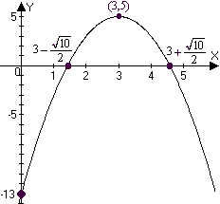
- has a vertex at (3,5) and intercepts at and . The graph is shown at right.
- seconds.
- . Evidently, (Pythagorean triplet 28,45,53).
- Let , then by Pythagoras:
Now, , so .
- .
- Let and then, by symmetry, and the area of trapezoid FJCG is . Now . Also, since we have similar triangles, . Thus the area of the trapezoid is .
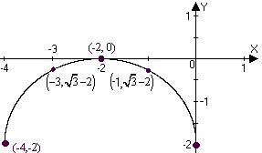
- The domain is all real numbers. The range is .
- has domain and range . The table of values leads to the graph of the half circle shown at right.
- .
- .
Thus the solutions are and .
- , but only the solution is valid in the original equation.
- .
- .
- The slope is which gives the yearly rate of change (in thousands per year.) Thus the linear model predicts a population of thousand in the year 2000.
- The “growth” factor is , so the exponential model predicts a population of thousand for the year 2000.
- so the coefficient of is 2.
- .
- .
- If , .
- The interest rate per month is about 0.0066666%. After one month the balance due on the loan will be . After two months the balance due will be .
- has so the 35th term is .
- .
- .
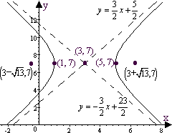
- has center at (3,7), vertices at , foci at and the asymptotes along and .
- Substituting into we get .
The corresponding x values are .
- .
- One approach is to enter the coefficient matrix and then left-multiply the RHS by the inverse of this matrix, as shown below: 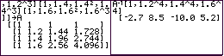
Alternatively, use the “SIMULT” feature found on the TI-85.
In either case, we approximate
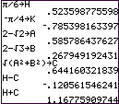
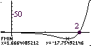
- The foci are at where , and . An efficient way to approximate these is to store coefficient approximations and then use these as shown in the screen shots. The foci are near and .
- In the graph at right, the TI-85 graph is shown with the results of using the MATH/FMIN feature on the graph menu. Apparently the minimum value is near . The maximum value is near .
- Solving the equation is equivalent to finding roots of the function (as on the TI85) The screen shots below show the results of using the MATH/ROOT feature on the graph menu of the TI-85. The roots are near where .
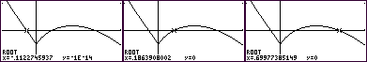
- The graphs below show C as a function of t over 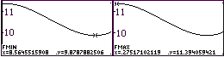
- As the graph shows, the maximum coffee consumption was about 11.4 million barrels per day in 1970 and the minimum consumption was about 9.9 million barrels per day in 1978.
- . A short calculation (shown to the right) gives . Also,
- Using the SUM/SEQ feature of the TI-85 as shown to the lower right,

