Final Exam/Form B Name: ______________________
Directions: Show all work. Section: _____________________

- Which one of the following equations describes a line passing through the origin and perpendicular to ?

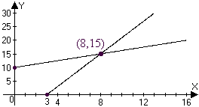
- The graph below shows the solution to which one of the following systems of equations?

- Which one of the following gives both solutions to the equation

- Which one of the following represents the solution to the inequality ?

- If , then

- Which equation represents a circle with radius 10 and center at ?

- Which one of the following exponential functions best fits the table of values?
 |  | 0 |  | 4 | 8
 |  | 10.5 |  | 10.67 | 10.85

- Which one of the following rational functions has vertical asymptotes along the lines and ?

- Which one of the following gives the first 6 terms of the sequence defined recursively by

- Observe that satisfies the horizontal line test. Which one of the following is a table of values for the inverse function, ?

- Find coordinates for the vertex and intercepts of the parabola .
- Write an equation for the line with slope and x-intercept .

- Given that a line has slope and y-intercept , complete the table:
 | 0 | 3 | 6 | 9

- The kilowatt-hour (kWh) is a unit of energy. Information about the energy used by 3-bedroom house (measured in kWh) per time (in hours) over the course of a day is tabulated below. Is the energy being used at a linear rate? If not, why not? If so, what is the rate of energy consumption measured in kWh per hour?
Time (in hours) | 0 | 6 | 18 | 24
Kilowatt-hours used (kWh) | 0.00 | 4.08 | 23.03 | 58.08

- Find an equation for the line perpendicular to and passing through the midpoint of the line segment joining and .
- In September 1996 the population of Glossy Black-Cockatoos on Kangaroo Island was estimated at 190 individuals. A previous estimate was taken in September of 1993 counted about 100 Cockatoos on Kangaroo Island. Assuming that the rate of growth of the Glossy Black-Cockatoos on Kangaroo Island was linear over this time, find a formula for the population of Glossy Black-Cockatoos on Kangaroo Island t years since September of 1993.
- Solve the system by back substitution:

- Solve the system using Gaussian elimination on an augmented matrix.

- A coin collection consists of pennies, nickels and dimes. There are 106 coins. The total value of the coins $9.36. The number of pennies is one more than twice the number of nickels. Set up and solve a system of equations to find how many of each type of coin there are.

- Find an equation for the parabola with a vertex at the origin and that passes within a distance 0.01 of .

- Simplify exact values for both solutions to the equation .
- Simplify exact values for the coordinates of the intercepts and the vertex of the parabola . Sketch a graph showing these features.
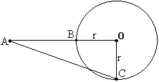
- A projectile is thrown upwards off a cliff so that its height (in feet) relative to the top of the cliff after t seconds is given by . When will the object have fallen 17 feet below the top of the cliff?
- In the diagram at right, is a right triangle with right angle at the origin, O. Solve for r if AC = 85 and AB = 41.
- In the diagram at right, express the value of AB in terms of r if AC = 5r.
- Use the quadratic formula to solve the following equation for h in terms of r: .
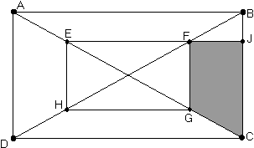
- As shown in the diagram at right, the vertices of rectangle EFGH lie on the diagonals of rectangle ABCD. If , and , find the area of trapezoid FJCG.
- Make a table of values showing at least 5 coordinate pairs and sketch a graph of the function . State the domain and range of the function .
- Find the domain and range of the function , partially graphed below: 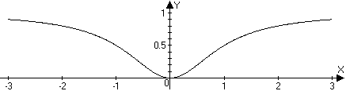
- Simplify .
- Find two real solutions to the equation: .
- Find both solutions to the equation: . Hint: Isolate a square root and equate squares twice.
- Solve for n: .
- Find x so that .
Questions 35 and 36 relate to the following table showing population data for Russian women between the ages of 15 and 49. Population numbers are in thousands.
- Use a linear model to fit the data for years 1990 and 1995. What population does this linear model predict for 2000?
- Use an exponential model to fit the data for years 1990 and 1995. What population does the exponential model predict for 2000?
- What is the coefficient of in the expansion of the product ?
- Write the product as a single fraction in lowest terms: .
- Find x so that .
- Solve for b in the equation . Assume that .
- Alberta borrowed $20,000 at 6% annual interest to buy a truck. If the interest is compounded monthly and she pays $750 per month towards the loan, how much does she owe after 2 monthly payments?
- Find the 25th term in the arithmetic sequence:
- Evaluate the series algebraically: .

- Solve for r: .

- Find the center, vertices, foci and asymptotes for the hyperbola given by the equation and sketch a graph showing these features.

- Determine the exact coordinates of the points where the line intersects the ellipse in simplified radical form.

- Find an equation for the ellipse whose graph is shown. 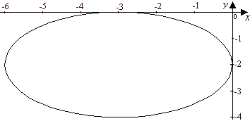
- Use a calculator to approximate to the nearest hundredth the solution to a system in variables with the following augmented matrix:
- Approximate to the nearest hundredth the coordinates of the foci of the ellipse described by

- Use a calculator to help make a graph of the function for . Approximate maximum and minimum values for the function on this interval to the nearest thousandth.
- There are three real solutions to the equation . Use a calculator to find 4-digit approximations for all three.
The number (in thousands) of sheep and lambs S in the United States in the years between 1985 and 1992 is modeled by the function, where t is the number of years since 1985. Questions 52 and 53 refer to this model.

- Graph the function to describe the lamb and sheep population from 1985 through 1992.
- According to the model, in what year did the lamb and sheep population stop decreasing and start increasing? In what year did the population stop increasing and start decreasing?
- Given, use a calculator to approximate to the nearest hundredth. For what value of r is ?

- Use a calculator to approximate correct to the nearest hundredth.

Solutions For Final Exam/Form B.
- e | - c | - d | - e | - a | - c | - d | - e | - e | - d
- The vertex of is at . Intercepts are at and .
- .
- .
- For the first 6 hours, the energy consumption rate is . For the next 12 hours, the rate is . Since the slope is not nearly constant, the rate of energy consumption is not nearly linear.
- The midpoint of and is and the perpendicular slope is , so an equation for the perpendicular bisector is .
- Let t represent the number of years since 1993. The linear rate of change is , so the population t years after 1993 is .
- . So the sol’n is .
- Let p represent the number of pennies; n, the number of nickels and d, the number of dimes in the coin collection. From the given information we set up the system So , and .
- and So
- .
- seconds.
- . Evidently, (Pythagorean triplet 36,77,85)
- Let , then by Pythagoras
Now, , so .
- .
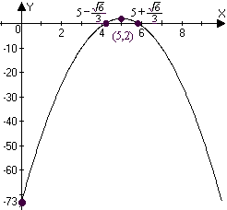
- has a vertex at (5,2) and intercepts at ,. The graph is shown at right.
- Let and then, by symmetry, and the area of trapezoid FJCG is .
Now . Also, since we have similar triangles, . Thus the area of the trapezoid is .
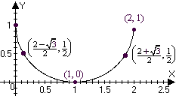
- has domain and range .
The table of values
leads to the graph of the half circle shown at right.
- The domain is all real numbers. The range is .
- .
- . Thus the solutions are and .
- , but only the solution is valid in the original equation.
- .
- The slope is which gives the yearly rate of change (in thousands per year.) Thus the linear model predicts a population of thousand in the year 2000.
- The “growth” factor is , so the exponential model predicts a population of thousand for the year 2000.
- so the coefficient of is 0.
- .
- .
- If , then .
- The interest rate per month is 0.5%. After one month the balance due on the loan will be . After two months the balance due on the loan will be .
- has so the 25th term is .
- .
- .
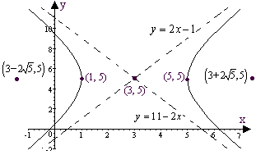
- has center at (3,5), vertices at , foci at and the asymptotes are along and . A graph is above.
- Substituting into we get . The corresponding y values are , so the points of intersection are and .
- .
- One approach is to enter the coefficient matrix and then left-multiply the RHS by the inverse of this matrix, as shown below: 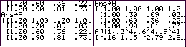
Alternatively, use the “SIMULT” feature found on the TI-85:
In either case, we approximate
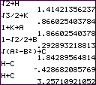
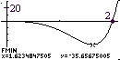
- The foci are at where , and . An efficient way to approximate these is to store coefficients and then use these as shown in the screen shots. The foci are near and .
- In the graph at right, the TI-85 graph is shown with the results of using the MATH/FMIN feature on the graph menu. Apparently the minimum value is near . The maximum value is near .
- Solving the equation is equivalent to finding roots of the function (as on the TI85) The screen shots below show the results of using the MATH/ROOT feature on the graph menu of the TI-85. The roots are near where .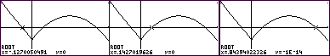
- The graphs below show S as a function of t over 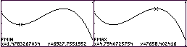
- As the graphs show, lamb and sheep population stopped decreasing and started increasing in 1986 and stopped increasing and started decreasing sometime in 1989.
- .
A Short calculation shows this is about 35.63:. Also, .
- Using the SUM/SEQ feature of the TI-85,

