Final Exam/Form A Name: __________________________
Directions: Show all work. Section: _________________________

- Which one of the following equations describes a line passing through the origin and perpendicular to ?

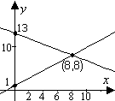
- The graph below shows the solution to which one of the following systems of equations?

- Which one of the following gives both solutions to the equation

- Which one of the following represents the solution to the inequality ?

- If , then

- Which equation represents a circle in the x-y plane with radius 7 and center at ?

- Which one of the following exponential functions best fits the table of values?
 |  | 0 |  | 10 | 20
 |  | 1.040 |  | 1.528 | 2.245

- Which one of the following rational functions has vertical asymptotes along the lines and ?

- Which one of the following gives the first 6 terms of the sequence defined recursively by

- Observe that satisfies the horizontal line test. Which one of the following is a table of values for the inverse function, ?

- Find coordinates for the vertex and intercepts of the parabola .
- Write an equation for the line with slope and x-intercept .

- Given that a line has slope and y-intercept , complete the table:
 | 0 | 10 | 20 | 40

- The kilowatt-hour (kWh) is a unit of energy. Information about the energy used by 3-bedroom house (measured in kWh) per time (in hours) over the course of a day is tabulated below. Is the energy being used at a linear rate? If not, why not? If so, what is the rate of energy consumption measured in kWh per hour?
Time (in hours) | 0 | 6 | 18 | 24
Kilowatt-hours used (kWh) | 0.00 | 5.21 | 40.64 | 63.00

- Find an equation for the line perpendicular to and passing through the midpoint of the line segment joining and .
- The Karner blue butterfly was listed as an Endangered Species in December 1992. Although the butterfly is found in ten states, it has declined significantly in most of those states; it is thought to no longer exist in three states where it previously existed. An example of the decline experienced by this butterfly is seen in the Albany, New York Pine Bush population, which declined from approximately 80,000 butterflies in August of 1979 to about 200 in August of 1990. If we assume that the rate of decline of the Karner blue butterfly was linear over this time, then find a formula for the population of Karner blue butterflies in Albany t years since August of 1979.
- Solve the system by back substitution:

- Solve the system using Gaussian elimination on an augmented matrix.

- A collection of 41 coins consists of pennies, nickels and dimes worth $1.92. The number of nickels is 2 more than the number of dimes. Set up and solve a system of equations to find how many of each type of coin there are.

- Find an equation for the parabola whose vertex is within a distance 0.01 of and that passes with in a distance 0.01 of the origin.

- Simplify exact values for both solutions to the equation .
- Simplify exact values for the coordinates of the intercepts and the vertex of the parabola . Sketch a graph showing these features.
- A projectile is shot upwards so that its height (in feet) after t seconds is given by . At what times will it be at a height of 58 feet?
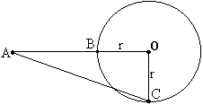
- In the diagram at right, is a right triangle with right angle at the origin, O. Solve for r if AC = 85 and AB = 41.
- In the diagram at right, express the value of AB in terms of r if AC = 3r.
- Use the quadratic formula to solve the equation for y in terms of x: .
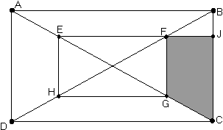
- As shown in the diagram at right, the vertices of rectangle EFGH lie on the diagonals of rectangle ABCD. If , and , find the area of trapezoid FJCG..

- Make a table of values showing five coordinate pairs, sketch a graph and state the domain and range of the function .
- Find the domain and range of the function partially graphed below:
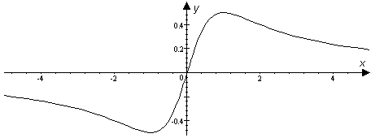

- Simplify .
- Find two real solutions to the equation: .
- Find both solutions to the equation: .
- Solve for x: .
- Find b so that .
Questions 35 and 36 relate to the table showing population data for Armenian girls less 15 years old:
- Use a linear model to fit the data for years 1996 and 1997. What population does this linear model predict for 1998?
- Use an exponential model to fit the data for years 1996 and 1997. What population does the exponential model predict for 1998?
- What is the coefficient of in the expansion of the product ?
- Write the product as a single fraction in lowest terms: .
- Find x so that .
- Solve for a in the equation
- Alfred borrowed $10,000 at 12% annual interest for a small business venture. If the interest is compounded monthly and he pays $500 per month towards the loan, how much does he owe after 2 monthly payments?
- Find the 15th term in the arithmetic sequence:
- Evaluate the series algebraically: .

- Solve for t: .

- Find the center, vertices and asymptotes for the hyperbola given by the equation and sketch a graph showing these features.

- Determine the exact coordinates of the points where the line intersects the ellipse in simplified radical form.

- Find an equation for the ellipse whose graph is shown. 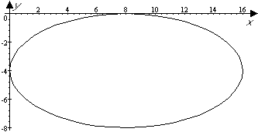
- Approximate to two significant digits the solution to a system of equations in with the augmented matrix:
- Approximate to the nearest hundredth coordinates of the vertex of the parabola described by .

- Use a calculator to help make a graph of the function for . Approximate maximum and minimum values for the function on this interval to the nearest thousandth.
- There are three real solutions to the equation . Use a calculator to find 4-digit approximations for all three.
Daily coffee consumption in the United States has varied considerably over the years. Suppose the equation models the number of cups per day C consumed by the average adult in year t (with 1955 corresponding to t = 0). Questions 52 and 53 refer to this model.

- Graph the equation to show daily coffee consumption from 1955 through 1992.
- According to the model, in what year was daily coffee consumption least? In what year was coffee consumption greatest?
- Given, use a calculator to approximate to the nearest hundredth. For what value of r is ?

- Use a calculator to approximate correct to the nearest hundredth.

Solutions For Final Exam/Form A.
- c | - d | - e | - b | - a | - d | - b | - d | - a | - b
- The vertex of is at . The intercepts are at and .
- For the first 6 hours, the energy consumption rate is . For the next 12 hours, the rate is . Since the slope is not nearly constant, the rate of energy consumption is not nearly linear.
- The midpoint of and is and the perpendicular slope is , so an equation for the perpendicular bisector is .
- Let t represent the number of years since 1979. The linear rate of change is , so the population t years after 1979 is .
- . So the sol’n is .
.
- Let p represent the number of pennies; n, the number of nickels and d, the number of dimes in the coin collection. From the given information we set up the system So , and .
- and So
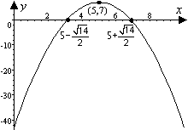
- has a vertex at (5,7) and intercepts at ,. The graph is shown at right.

- seconds.
- . Evidently, (Pythagorean triplet 36,77,85)
- Let , then by Pythagorus
Now, , so .
- .
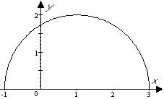
- Let and then, by symmetry, and the area of trapezoid FJCG is . Now . Also, since we have similar triangles, . Thus the area of the trapezoid is .
- has domain and range . The table of values leads to the graph of the half circle shown at right.
- The domain is all real numbers. The range is .
- .
- . Thus the solutions are and .
- , both solutions are valid in the original equation.
- .
- .
- The slope is which gives the yearly rate of change. Thus the linear model predicts a population of in 1998.
- The “growth” factor is , so the exponential model predicts a population of for 1998.
- shows the coefficient of is 3.
- .
- .
- .
- The interest rate per month is 1%. After one month the balance due on the loan will be . After two months the balance due on the loan will be .
- has so the 15th term is .
- .
- .
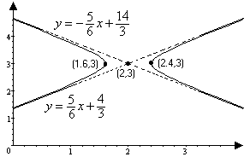
- has center at (2,3), vertices at and the asymptotes are along and .
- Substituting into we get . The corresponding x values are .
- .
- One approach is to enter the coefficient matrix and then left-multiply the RHS by the inverse of this matrix, as shown below: 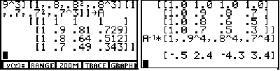
Alternatively, use the “SIMULT” feature found on the TI-85: 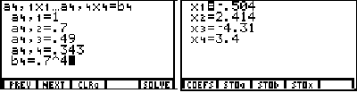
In either case, we approximate
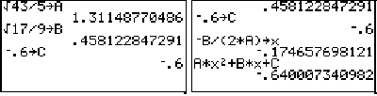
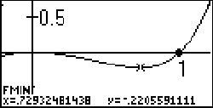
- The vertex is where . An efficient method of computation is to store coefficient approximations and then use these as shown in the screen shots. The vertex is near .
- In the graph at right, the TI-85 graph is shown with the results of using the MATH/FMIN feature on the graph menu. Apparently the minimum value is near . The maximum value is near .
- The screen shots below show the results of using the MATH/ROOT feature on the graph menu of the TI-85. Also shown (upper right) is the use of the solver. Note that the exponent 5/3 or 2/5 does not produce negative roots, so the radical notation is used instead. The roots are near where .
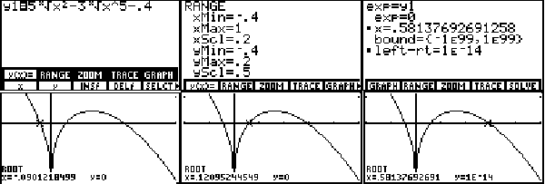
- The graph below shows C as a function of t over 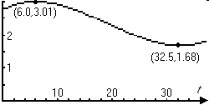
- As the graph shows, the maximum coffee consumption was about 3 cups per day in 1961 and the minimum consumption was about 1.7 cups per day in 1987.
- . A Short calculation shows this is about 97.23:. Also, .
- Using the SUM/SEQ feature of the TI-85, the sum is found to be about 1321.50 