CHAPTER 11 TEST C Name: __________________________
Directions: Show all work. Section: _________________________

- Which one of the following formulas could describe the graph below?
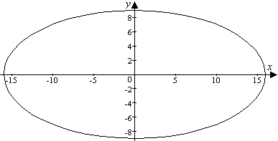

- Which one of the following equations represents a parabola with focus at ?

- The ellipse with vertices at and , covertices at and is represented by which one of the following equations?

- Which one of the following coordinates describes the point in the first quadrant where the hyperbola intersects the circle of radius 3, centered at the origin?
- Which one of the following shows the solution to the system of inequalities:
- 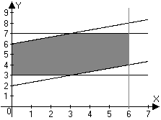 | - 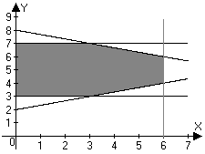
- 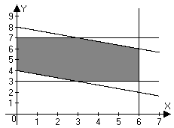 | - 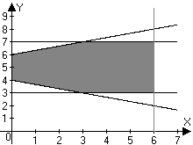

- Information about the age distributions in three different villages (A, B and C) is given in the box plots shown below. Which one of the following statements about these trees below is not true? 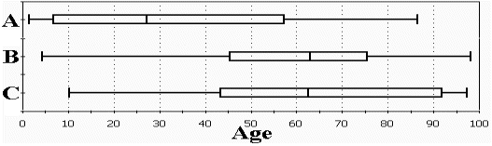
  - The oldest person lives in village B.
  - The median age of people in village C is greater than the age of three quarters of the people in village A.
  - Half the people in Village A are less than 28 years of age.
  - More than one quarter of the people in village C are older than the oldest person in village A.
  - Village A has the greatest range of ages.
- Find the lengths of the major and minor axes and the coordinates of the foci for the ellipse described by the equation and sketch a graph for the ellipse showing these features.
- Find coordinates for the points on the ellipse where .
- Find the coordinates of the vertices and the equations for the asymptotes of and use these to sketch a graph of the hyperbola.
- Find an equation for the parabola with a vertex at the origin and a focus at . Sketch a graph for the parabola showing these features.
- Find an equation for the parabola with vertex at and focus at . Sketch a graph of the parabola showing these features together with the directrix.
- Find the coordinates of the focus and an equation for the directrix of the parabola described by . Sketch a graph for the parabola showing these features.
- Find the center and the lengths of the major and minor axes of the ellipse described by the equation . Sketch a graph for the ellipse showing these features.
- Find the center, vertices and asymptotes for the hyperbola given by the equation .
- Find an equation for hyperbola shown below: 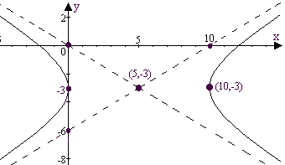
Problems 16-20 will solve a linear programming problem for the following situation:

The manager of a bakery has asked his assistant for a cost analysis to help determine what cakes to bake. They can bake two types of cakes: a bundt cake and a more expensive porter cake, made with Irish whiskey. The assistant must figure out how many of each type of cake to bake so to minimize production costs. It is required that they sell at least 150 cakes (some combination of bundt and porter cakes.) A bundt cake earns $13 in profit for the bakery, while a porter cake brings in a $21 profit. Total profits on bundt and porter cakes must be at least $2470. The bundt cake production cost is $8. The production cost for a porter cake is $12.
- Let b represent the number of bundt cakes the bakery bake order and let p represent the number of porter cakes they bake. Write the constraints of the problem as inequalities in terms of b and p.
- Write the objective function of the problem in terms of b and p.
- Sketch the solution set to the constraint system.
- Find the coordinates of the vertices of the solution set.
- Find the combination of bundt and porter cakes that minimizes cost. What is this minimum cost?
- Approximate to four significant digits the coordinates of the foci of the ellipse given by .
- The equation can be solved for y using the quadratic formula. For a given x there may be two solutions: . Graph these two functions on a calculator and describe what you see in terms of a conic section.
- Use a calculator to approximate to 5 significant digits the values of x that solve the system: .

Problems 24 and 25 refer to the following linear programming problem:
:
maximize
such that
- Approximate to 4 significant digits the vertices of the solution region for the constraint system. Sketch a graph of the constraint system to show these.
- Approximate to four significant digits the maximum value of over the solution set of the constraint system.
Solutions For Chapter 11 Test Form C.
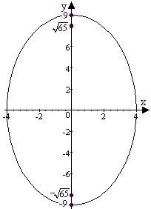
- f | - e | - c | - e | - d | - d

- The major axis has length 18 and the minor axis has length 8 while the foci are at .
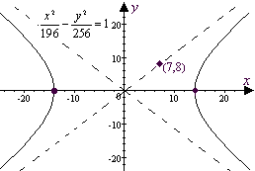
- . So the coordinates of intersection points are .
- The vertices of the hyperbola are at and the asymptotes are , as shown to the right:
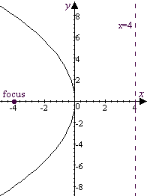
- An equation for the parabola is and a graph is shown below.

- An equation for the parabola is , as shown below:
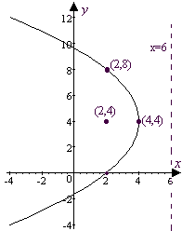

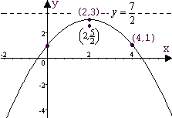
- An equation for the directrix of is . The parabola is shifted up 3 (and over 2), so the directrix is shifted to . The horizontal shift doesn’t affect the directrix. The focus is at , as shown.
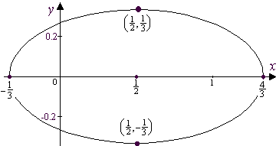
- .
So the length of the major axis is and the length of the minor axis is . The ellipse is centered at as shown at right.
- is centered at with vertices at and at and asymptotes along and .
- Starting with the form , observe that the point (0,0) is on one asymptote, so that and , and the hyperbola is given by .
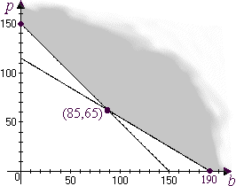
- The constraint system is .
- The cost function, , is to be minimized.
- See plot at right:
- As shown in the illustration, the vertices of the solution set are , and .
- The cost function is minimized at where C = $1460.
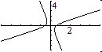
- The foci are at where , thus the foci are near and .
- These two functions comprise a hyperbola whose axes are tilted and whose center is near the origin, as shown at right.

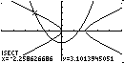
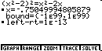
- We have a hyperbola and a parabola. Graphing these shows there are two points of intersection. The coordinates can be found (on the TI-85) by either using ISECT or by using the solver, as shown. or

- As the first two screen shots below show, the solution region for the constraint set is a rhombus with origin symmetry. The vertices are approximated by , , and .
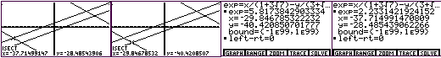
- The maximum value of the objective function is then found using the “solver.”
Evidently, a maximum value of about is attained near .

