CHAPTER 11 TEST B Name: ______________________
Directions: Show all work. Section: _____________________

- Which one of the following formulas could describe the graph below?
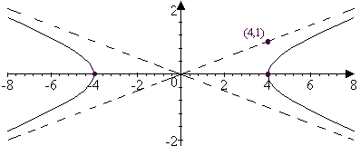

- Which one of the following equations represents a parabola with focus at ?

- The ellipse with vertices at and , covertices at and is represented by which one of the following equations?

- Which one of the following equations represents a hyperbola centered at , vertices at , and asymptotes ?

- Which one of the following shows the solution to the system of inequalities:
- 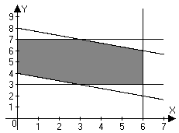 | - 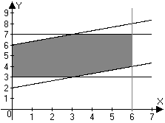
- 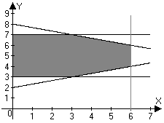 | - 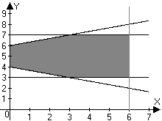

- Information about the age distributions in three different villages (A, B and C) is given in the box plots shown below. Which one of the following statements about these trees below is not true? 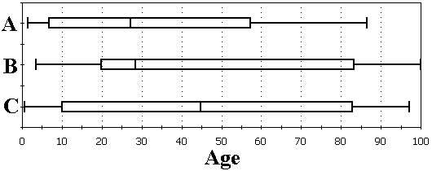
  - The youngest person lives in village C.
  - Inhabitants of village A have the youngest median age.
  - The median age of village A is greater than the first quartile age of village B.
  - One quarter of people in village B are older than the oldest person in village A.
  - One quarter of the inhabitants of village C are less than ten years of age.
- Find the lengths of the major and minor axes and the coordinates of the foci for the ellipse described by the equation and sketch a graph for the ellipse showing these features.
- Find coordinates for the points on the ellipse where .

- Find the coordinates of the vertices and the equations for the asymptotes of and use these to sketch a graph of the hyperbola.
- Find an equation for the parabola with a vertex at the origin and a focus at . Sketch a graph for the parabola showing these features together with the directrix.

- Find an equation for the parabola with a vertex at and a focus at . Sketch a graph for the parabola showing these features together with the directrix.
- Find the coordinates of the focus and an equation for the directrix of the parabola described by . Sketch a graph for the parabola showing these features.
- Find the center and the lengths of the major and minor axes of the ellipse described by the equation. Sketch a graph for the ellipse showing these features.
- Find the center, vertices and asymptotes for the hyperbola given by the equation
- Find an equation for hyperbola shown below: 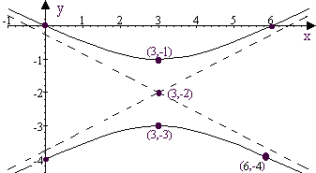
Problems 16-20 refer to the linear programming problem in the following situation:

The manager of a software retailer has asked her assistant for a cost analysis to help determine what software they will order. They are choosing between two types of database packages: Stackmaker, and a more expensive full-featured package called Deluxstack. The assistant must figure out how many packages of each software to order to minimize costs. It is required that they sell at least 300 packages (some combination of Stackmaker and Deluxstack.) A Stackmaker sale earns $18 in profit for the retailer, while a Deluxstack sale earns $24 in profit. Total profits on database software sales must be at least $6240. The wholesale cost of Stackmaker is $25. The wholesale cost Deluxstack is $40. The retailer buys software at the wholesale cost.

- Let s represent the number of Stackmaker packages the retailer will order and let d represent the number of packages of Deluxstack the company will order. Write the constraints of the problem as inequalities in terms of s and d.
- Write the objective function of the problem in terms of s and d.
- Sketch the solution set to the constraint system.
- Find the coordinates of the vertices of the solution set.
- Find the combination of Stackmaker and Deluxstack packages that will minimize cost. What is this minimum cost?
- Approximate to four significant digits the coordinates of the foci of the hyperbola given by .
- The equation can be solved for y using the quadratic formula. For a given x there may be two solutions: Graph these two functions on a calculator and describe what you see in terms of a conic section.
- Approximate to 4 significant digits the value(s) of x in the solution(s) to the system:
.
Problems 24 and 25 refer to the following linear programming problem:
:
maximize
such that
- Approximate to four significant digits the vertices of the solution region for the constraint system. Sketch a graph of the constraint system to show these.
- Find the maximum value of over the solution set of the constraint system.

Solutions For Chapter 11 Test Form B.
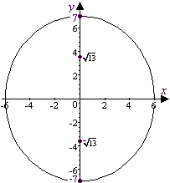
- b | - f | - a | - d | - b | - d
- The major axis has length 14 and the minor axis has length 12 while the foci are at .
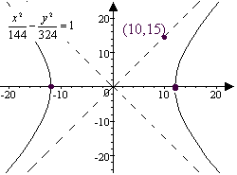
- .
- The vertices of the hyperbola are at and the asymptotes are , as shown to the right:
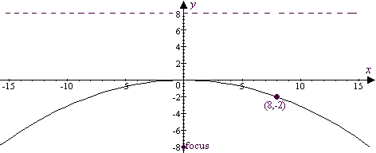
- is an equation for the parabola. The graph is shown below:
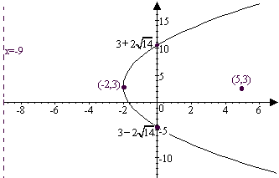
- The equation for the parabola is . The directrix is . The graph is shown below to the right:

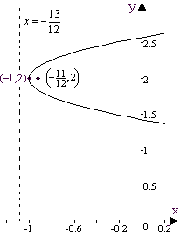
- The vertex of is at and the distance to the focus is so the focus is at and the directrix is .
A graph is shown at right:
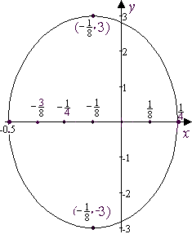
- . So the length of the major axis is and the length of the minor axis is . The ellipse is centered at as shown:
- . So the center is at , the vertices are at and the asymptotes are .
- Starting with the form , observe that the points and (0,0) are on the hyperbola so that and . Thus an equation for the hyperbola is .
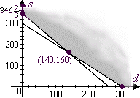
- The constraint system is .
- The cost function, , is to be minimized.
- See sketch to the right:
- As shown in the illustration, the vertices of the solution set are , and .
- The cost function is minimized at where C = $
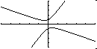
- The foci are at where
Thus the foci are near and .
- These two functions comprise a hyperbola whose axes are tilted and whose center is near the origin, as shown at right.
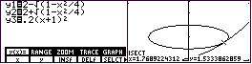
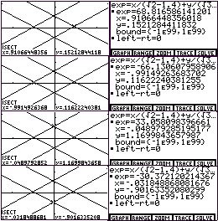
- Plotting the three functions involved and using the “ISECT” feature on the TI-85 shows that there appears to be only one point of intersection near where
- As the screenshots at right show, the feasible region is a rhombus with vertices near , , , and .
- Evidently, the maximum value of the object function is about 68.81 and is attained near .

