CHAPTER 11 TEST A Name: ______________________
Directions: Show all work. Section: _____________________

- Which one of the following formulas could describe the graph below? 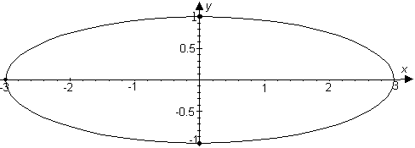

- Which one of the following equations represents a parabola with focus at ?

- The ellipse with vertices at and , covertices at and is represented by which one of the following equations?

- Which one of the following coordinates describes the point in the first quadrant where the hyperbola intersects the circle of radius 2, centered at the origin?
- Which one of the following shows the solution to the system of inequalities:
- 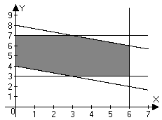 | - 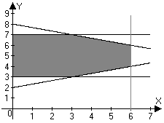
- 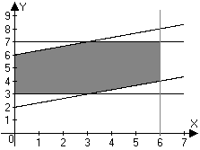 | - 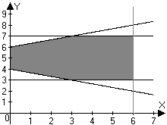

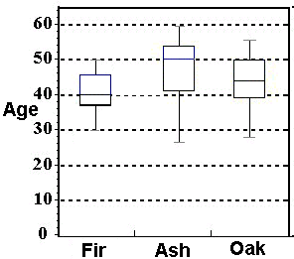
- Information about a forest that contains fir, ash and oak trees is given in the box plots shown at right. Which one of the statements about these trees below is not true?
  - The youngest tree is an ash.
  - The Fir trees have the youngest median age.
  - The median age of fir trees is less than the first quartile age of ash trees.
  - One quarter of the ash trees are older than the oldest oak tree.
  - Three quarters of the ash trees are older than the median age for fir trees.

- Find the lengths of the major and minor axes and the coordinates of the foci for the ellipse described by the equation and sketch a graph for the ellipse showing these features.
- Find coordinates for the points on the ellipse where .
- Find the coordinates of the vertices and the equations for the asymptotes of and use these to sketch a graph of the hyperbola.
- Find an equation for the parabola with a vertex at the origin and a focus at . Sketch a graph for the parabola showing these features together with the directrix.
- Find an equation for the parabola with vertex at and focus at . Sketch a graph of the parabola showing these features.
- Find the coordinates of the focus and an equation for the directrix of the parabola described by . Sketch a graph for the parabola showing these features.
- Find the center and the lengths of the major and minor axes of the ellipse described by the equation. Sketch a graph for the ellipse showing these features.
- Find the center, vertices and asymptotes for the hyperbola given by the equation
- Find an equation for hyperbola shown below: 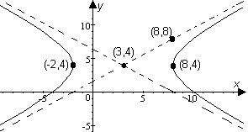
Problems 16-20 refer to the linear programming problem in the following situation:

The manager of a landscape agency has asked her assistant for a cost analysis to help determine what trees they will order. They are choosing between two types of trees: a 10 year-old tangerine and a more expensive 20 year-old pepper. The assistant must figure out how many of each tree to order to minimize costs. It is required that they sell at least 100 trees (some combination of tangerines and peppers.) Tangerines bring a $40 profit for the company, while peppers bring a $60 profit. Total profits on tangerine and pepper trees must be at least $4800. The wholesale cost of a tangerine tree is $250. The wholesale cost of a pepper tree is $400. The company buys at the wholesale cost.
- Let t represent the number of tangerine trees the company will order and let p represent the number of pepper trees the company will order. Write the constraints of the problem as inequalities in terms of t and p.
- Write the objective function of the problem in terms of t and p.
- Sketch the solution set to the constraint system.
- Find the coordinates of the vertices of the solution set.
- Find the combination of tangerine and pepper trees that minimizes cost. What is this minimum cost?
- Approximate to four significant digits the coordinates of the foci of the ellipse given by .
- The equation can be solved for y using the quadratic formula. For a given x there may be two solutions: Graph these two functions on a calculator and describe what you see in terms of a conic section.
- Approximate to two significant digits the solutions to the system:
.

Problems 24 and 25 refer to the following linear programming problem:
:
minimize
such that
- Use a calculator to approximate the vertices (to 3 digits) of the solution region for the constraint system. Sketch a graph of the constraint system to show these.
- Find the minimum value of over the solution set of the constraint system.
Solutions For Chapter 11 Test Form A.
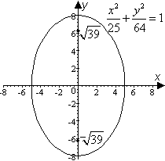
- e | - a | - d | - c | - a | - d

- The major axis has length 16 and the minor axis has length 10 while the foci are at .
- .
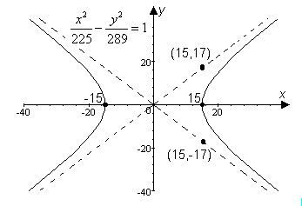
- The vertices of the hyperbola are at and the asymptotes are , as shown to the right:
- An equation for the directrix is . An equation for the parabola is and a graph is shown at below.
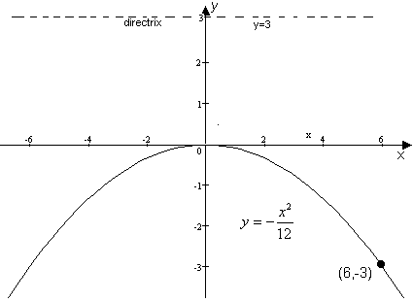

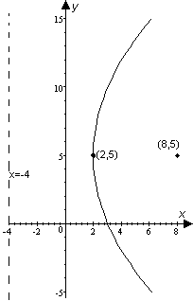
- If the vertex of a parabola is at and the focus is at , then the equation for the parabola is , as shown at right.
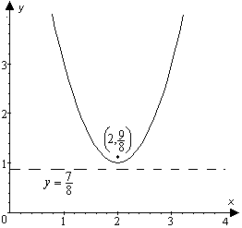

- An equation for the directrix of is . The parabola is shifted up 1, so the directrix is shifted to . The horizontal shift doesn’t affect the directrix. The focus is at , as shown above.
- . So the length of the major axis is and the length of the minor axis is . The ellipse is centered at as shown at right.
- is centered at with vertices at and at and asymptotes along and .
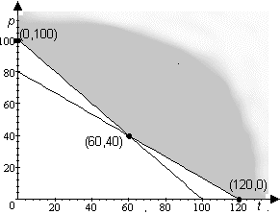
- Starting with the template we see from the point (8,8) on one asymptote that and , so the equation for the hyperbola is .
- The constraint system is .
- The cost function, , is to be minimized.
- See sketch to the right:
- As shown in the illustration above, the vertices of the solution set are , and .
- The cost function is minimized at where C = $30,000
- The foci are at where 0.5412. Thus the foci are at and
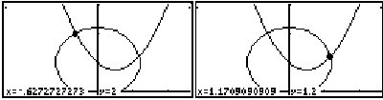
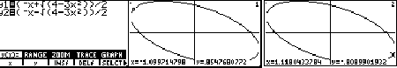
- These functions comprise a tilted ellipse; major vertices near
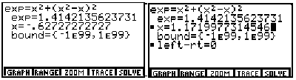
- A circle of radius is centered at and a parabola has vertex at . With “zoom square” and “draw circle” features of the TI-85, we arrive at the above graphs, indicating solutions near and . Substituting for y in the equation for the circle, we may use the TI-85 solver to find better approximations:

- The following screen shots show that the solution region for the constraint set is a rhombus with all vertices on the coordinate axes. We see that the vertices are approximated by and . 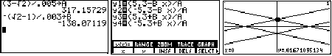

- The minimum value of is then found using the “solver:” 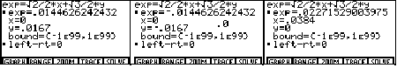
Evidently, a minimum value of about is attained at.

