CHAPTER 10 TEST C Name: ______________________
Directions: Show all work. Section: _____________________

- Which one of the following functions results from shifting nine units to the right and five units down?

- Which one of the following quadratic functions is a translation of two units to the right and five units up?

- Which of the following is a graph of the piecewise function:
?
- 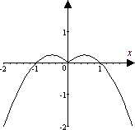 | - 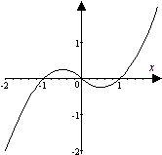 | - 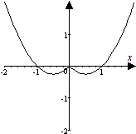
- 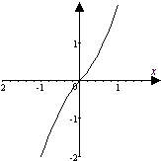 | - 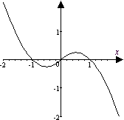 | - 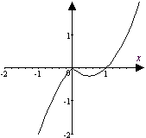

- Observe that satisfies the horizontal line test. Which one of the following is a table of values for the inverse function, ?

- Uranium 238 (U238) has a half-life of years. Thus 10 grams of U238 will decay according to the formula . Which one of the following gives a formula for t in terms of A?

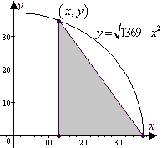
- A right triangle is inscribed in the quarter circle with radius 37 as shown in the diagram. Which one of the formulas below gives the area of the triangle as a function of the x-coordinate of the vertex on the semicircle, ?

- Describe how is a transformation of .
- Identify the scale factor in the function and describe how it affects the corresponding basic function.
- Write in the form by completing the square. Use the horizontal and vertical translations of to help sketch a graph of showing exact coordinates of all intercepts.
- Sketch graphs for the basic log function and the transformation together, showing coordinates of three points on each graph.
- Graph the piecewise defined function:
- Complete the table of values for the function and use the results to sketch graphs for and together showing symmetry through the line .
- Find the inverse function g for and show that .

- Without using a graph, show does not satisfy a horizontal line test.
- If , find .
- The perimeter of a right triangle is 30 units and one leg is 2 more than 2 times the other leg. Use algebra to find the length of the legs.
- Carburetor size (measured in cubic feet of air per minute, cfm) varies jointly with engine cubic inch displacement (CID) and maximum engine speed in revolutions per minute (rpm). If an engine with 345CID and 5500rpm measures 550cfm, approximate the measure of a carburetor with 400CID and 6500rpm.
- The volume V of a gas varies inversely as the pressure P on it and directly with T its temperature. Pressure is measured in atmospheres (atm) and temperature in degrees Kelvin . Find the volume of gas at a pressure of 1.00atm and temperature if its volume is 2 Liters at pressure 1.80atm and temperature .
- The power output of a windmill varies jointly with the square of the propeller’s diameter and the cube of the wind velocity. Using table at right, compute the constant of proportionality and determine the power that would be produced by a propeller with 26-foot diameter in a 10 mph wind.
Propeller Diameter in Feet | Wind Velocity in mph
Propeller Diameter in Feet | 15 | 20 | 25 | 30
18 | 1320 | 3060 | 6000 | 10350
20 | 1600 | 3600 | 7360 | 12760
22 | 1940 | 4350 | 8900 | 15420
24 | 2300 | 5180 | 10650 | 18380
 | Windmill Power Output in Watts

- Tidal data for the Pandora Wreck Site in Queensland for July 16-20, 2000 are plotted below. The tides are nearly periodic. Observing the times for high and low tides given for each day, approximate length of the period to the nearest hour. 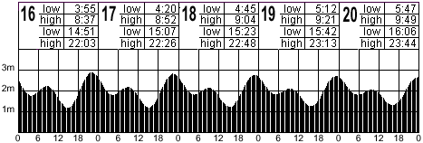

- Use a calculator to approximate if .

- Use a calculator to approximate the solution to accurate to 5 digits.
- The road surrounding the Lake Ovoid has a shape given by . Approximate coordinates on the road that are at a distance of 4 units from the origin.
- Use a calculator to help sketch a graph of the function . Does this function satisfy the horizontal line test?
- Use a calculator to help plot the piecewise function .
Does this function satisfy the horizontal line test?

Solutions For Chapter 10 Test Form C.

- a | - e | - f | - b | - c | - c
- is shifted 12 units to the left and 23 units down.
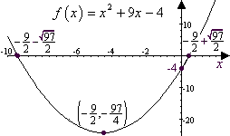
- is a vertical expansion by a factor of , following a shift of one to the right and reflections through the y-axis and the x-axis of the basic function .
- 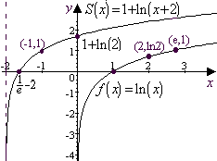
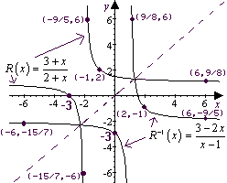
- 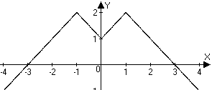
- .
- .
- .
- Let x represent the length of the shorter leg. Then the longer leg is 2x+2 and the hypotenuse is The Pythagorean theorem then yields
x = 39 wouldn’t allow a perimeter of 30, so choose x = 5 and 2x + 2 = 12.
- . So the carburetor with CID = 400 and rpm = 6500 should measure .
- . At 1.00 atm, .
- Watts.
- Tracking the lower high tides: period
Similarly, tracking the higher low tides gives an average period of 1458 minutes; the lower low tide has an average period of 1458.75 min. and the higher high tide has an average period of 1465.25 min. Thus the average period is about 1461.8 minutes, or 24.36 hours. Evidently, the period, to nearest hour, is 24 hours.
- One way to do this is to enter the function formula on the graph page and then use the recursive properties of the home page to iterate the function to get 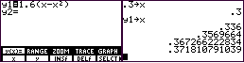
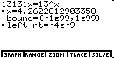
- Using the “SOLVER” feature on the TI-85 calculator, we find that
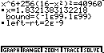
- Points 4 units from the origin satisfy . Substituting into yields . Using the “SOLVER” feature on the TI-85, we find that so that and the four points a distance 16 units from the origin are
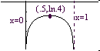
- does not satisfy the horizontal line test since .
- On the TI-85, the composite function can be entered as .
Evidently, it doesn’t satisfy the horizontal line test.
