CHAPTER 10 TEST B Name: ______________________
Directions: Show all work. Section: _____________________

- Which one of the following functions results from shifting
four units to the left and seven units up?

- Which one of the following rational functions is a translation of
eight units to the left and five units down?

- Which of the following is a graph of the piecewise function: ?
- 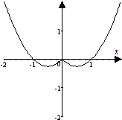 | - 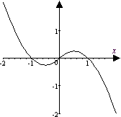 | - 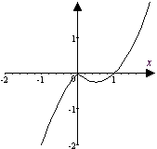
- 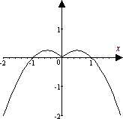 | - 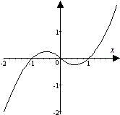 | - 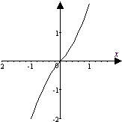

- Observe that satisfies the horizontal line test. Which one of the following is a table of values for the inverse function, ?

- Radon 222 (Rn222) has a half-life of 3.825 days. Thus 100 grams of Rn222 will decay according to the formula .
Which one of the following gives a formula for t in terms of R?
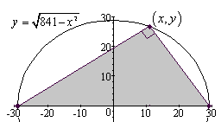
- A right triangle is inscribed in the semicircle with radius 29 as shown in the diagram. Which one of the functions below gives the area of the triangle as a function of the x-coordinate of the vertex on the upper half of the circle ?

- Describe how is a transformation of .
- Identify the scale factor in the function and describe how it affects the corresponding basic function.
- Write in the form by completing the square. Use the horizontal and vertical translations of to help sketch a graph of showing exact coordinates of all intercepts.
- Sketch graphs for the basic reciprocal function and the transformation together in the same coordinate plane, showing asymptotes and coordinates of two points on each graph.
- Graph the piecewise defined function:
- Complete the table of values for the rational function and use the results to sketch graphs for and together in the same coordinate plane, showing symmetry through the line .
- Find the inverse g of the function and show that .

- Without using a graph, show does not satisfy the horizontal line test.
- If , find .
- The perimeter of a right triangle is 70 units and one leg is 1 unit longer than the other leg. Use algebra to find the length of the legs.
- Carburetor size (measured in cubic feet of air per minute, cfm) varies jointly with engine cubic inch displacement (CID) and maximum engine speed in revolutions per minute (rpm). If an engine with 425CID and 8000rpm measures
986cfm, approximate the measure of a carburetor with 750CID and 6000rpm.
- The volume V of a gas varies inversely as the pressure P on it and varies directly with T its temperature. Pressure is measured in atmospheres (atm) and temperature is measured in degrees Kelvin . Find the volume of gas at pressure 1.25atm and temperature if its volume is 25 Liters at pressure 3.00atm and temperature.
- The power output of a windmill varies jointly with the square of the propeller’s diameter and the cube of the wind velocity. Using table at right, compute the constant of proportionality and determine the power that would be produced by a propeller with 18-foot diameter in a 35 mph wind.
Propeller Diameter in Feet | Wind Velocity in mph
Propeller Diameter in Feet | 10 | 15 | 20 | 25
10 | 120 | 400 | 950 | 1840
12 | 170 | 540 | 1360 | 2660
14 | 230 | 735 | 1850 | 3620
16 | 300 | 1040 | 2440 | 4740
 | Windmill Power Output in Watts

- Tidal data for the Pandora Wreck Site in Queensland for July 9-13, 2000 are plotted below. The tides are nearly periodic. Observing the times for high and low tides given for each day, approximate length of the period to the nearest hour. 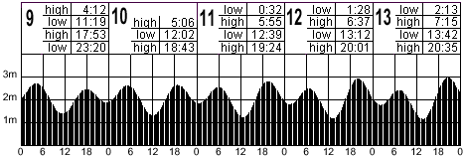

- Use a calculator to approximate if .

- Use a calculator to approximate the solution to accurate to 5 digits.
- Juanita operates a toy car that goes around a track whose shape is given by . Use a calculator to approximate the coordinates on the track that are at distance of 3.5 units from the origin.
- Use a calculator to help sketch a graph of the function . Does this function satisfy the horizontal line test?
- Use a calculator to help plot the piecewise function .
Does this function satisfy the horizontal line test?

Solutions For Chapter 10 Test Form B.

- e | - b | - b | - c | - c | - a
- is shifted 31 units to the right and 71 units up.
- is a horizontal expansion by a factor of 2 and reflection through the x-axis of the basic function .
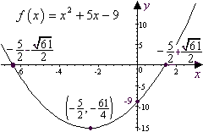
- 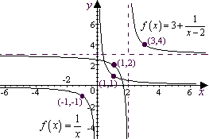
- 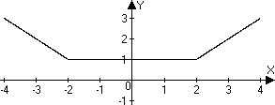

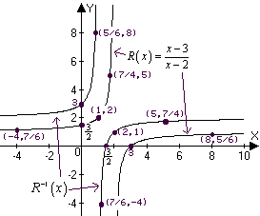
- .
- .
- Let x represent the length of the shorter leg. Then the longer leg is x+1 and the hypotenuse is The Pythagorean theorem then yields . x = 119 is too big, so choose x = 20 and x + 1 = 21.
- . So the carburetor with CID = 750 and rpm = 6000 will measure .
- . At 1.25atm, , .
- Watts.
- Tracking the higher high tides: period
Similarly, tracking the lower low tides gives an average period of 1476 minutes; the lower highs have an average period of 1480.25 min. and the second peak has an average period of 1497.67 min. Thus the average period is about 1484 minutes, or 24.7 hours. To the nearest hour then, the period is 25 hours.
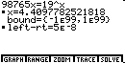
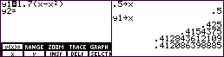
- One way to do this is to enter the function formula on the graph page and then use the recursive properties of the home page to iterate the function to get
- Using the “SOLVER” feature on the TI-85 calculator, we find that
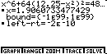
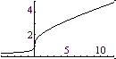
- If Juanita’s toy car is 3.5 units from the origin, then . Substituting into yields . Using the “SOLVER” feature on the TI-85, we find that so that and the four points 3.5 units from the origin are .
- satisfies the horizontal line test since increases with y and is increasing.
- On the TI-85, the composite function can be entered as
Evidently, it doesn’t satisfy the horizontal line test.
