CHAPTER 10 TEST A Name: ______________________
Directions: Show all work. Section: _____________________

- Which one of the following functions results from shifting eight units to the left and ten units down?

- Which one of the following quadratic functions is a translation of five units to the right and eight units down?

- Which of the following is a graph of the piecewise function: ?
- 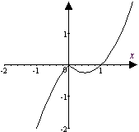 | - 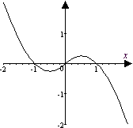 | - 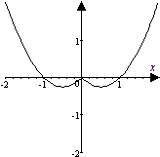
- 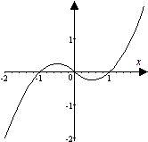 | - 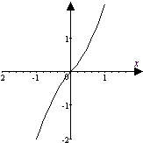 | - 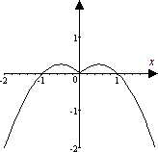

- Observe that satisfies the horizontal line test. Which one of the following is a table of values for the inverse function, ?

- Polonium 210 (Po210) has a half-life of 138.38 days. Thus 40 grams of Po210 will decay according to the formula .
Which one of the following gives a formula for t in terms of P?

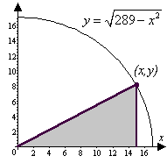
- A right triangle is inscribed in the quarter circle with radius 17 as shown in the diagram. Which one of the formulas below gives the area of the triangle as a function of the y coordinate of the vertex on the circle, ?

- Describe how is a transformation of .

- Identify the scale factor in the function and describe how it affects the corresponding basic function.
- Write in the form by completing the square. Use the horizontal and vertical translations of to help sketch a graph of showing exact coordinates of all intercepts.
- Sketch graphs for the basic root function and the transformation together in the same coordinate plane, showing coordinates of three points on each graph.
- Graph the piecewise defined function:
- Complete the table of values for the rational function and use the results to sketch graphs for and together in the same coordinate plane, showing symmetry through the line .
- Find the inverse function g of and show that

- Without using a graph, show does not satisfy the horizontal line test.
- If , find .
- The perimeter of a right triangle is 154 units and one leg is 10 less than 2 times the other leg. Use algebra to find the length of the legs.
- Carburetor size (measured in cubic feet of air per minute, cfm) varies jointly with engine cubic inch displacement (CID) and maximum engine speed in revolutions per minute (rpm). If an engine with a 375CID and 7000rpm measures 760cfm, approximate the measure of a carburetor with 700CID and 2000rpm.
- The volume V of a gas varies inversely as the pressure P on it and varies directly with T its temperature. Pressure is measured in atmospheres (atm) and temperature is measured in degrees Kelvin . Find the volume of gas at pressure 2.00atm and temperature if its volume is 300 Liters at pressure 0.25atm and temperature .
- The power output of a windmill varies jointly with the square of the propeller’s diameter and the cube of the wind velocity. Using table at right, compute the constant of proportionality and determine the power that would be produced by a propeller with 10-foot diameter in a 30 mph wind.
Propeller Diameter in Feet | Wind Velocity in mph
Propeller Diameter in Feet | 5 | 10 | 15 | 20
2 | 0.6 | 5 | 16 | 38
4 | 2 | 19 | 64 | 150
6 | 5 | 42 | 140 | 340
8 | 10 | 75 | 260 | 610
 | Windmill Power Output in Watts
- Tidal data for the Pandora Wreck Site in Queensland for July 2-6, 2000 are plotted below. The tides are nearly periodic. Observing the times for high and low tides given for each day, approximate length of the period to the nearest hour. 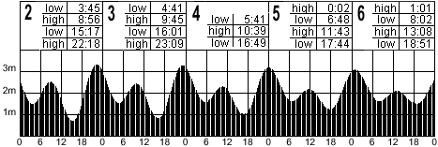

- Use a calculator to approximate if .

- Use a calculator to approximate the solution to accurate to 5 digits.
- Jose runs around a track whose shape is given by . Use a calculator to approximate the coordinates on the track that are at distance of 3 units from the origin.
- Use a calculator to help sketch a graph of the function . Does this function satisfy the horizontal line test?
- Use a calculator to help plot the piecewise function .
Does this function satisfy the horizontal line test?

Solutions For Chapter 10 Test Form A.

- c | - e | - d | - b | - c | - c
- is a shift of eleven units to the right and seventeen units up.
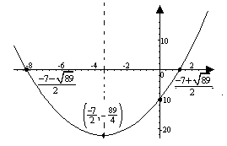
- is a vertical compression by a factor of and reflection through the x-axis of the basic function .
- 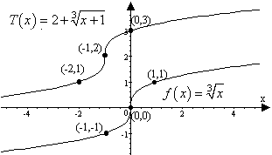
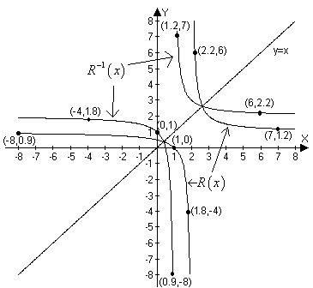
- 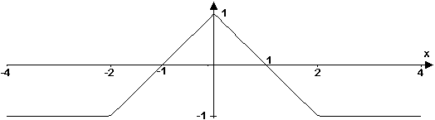
- .
- Let x represent the length of the shorter leg. Then the longer leg is 2x-10 and the hypotenuse is The Pythagorean theorem then yields . x = 203 is too big, so choose x = 33 and 2x - 10 = 56.
- . So the carburetor with CID = 700 and rpm = 2000 should measure .
- . So at 2.00 atm, the volume will be Liters.
- Watts.
- Tracking the first trough: period
Similarly, Tracking the first peak gives an average period of 1503 minutes; the second trough has an average period of 1493.5 min. and the second peak has an average period of 1494.3 min. Thus the average period is about 1499 minutes, or 25 hours.
- One way to do this is to enter the function formula on the graph page and then use the recursive properties of the home page to iterate the function to get 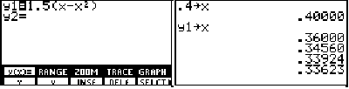
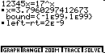
- Using the “SOLVER” feature on the TI-85 calculator, we find that
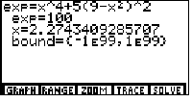
- If Jose is 3 units from the origin, then and substituting into the equation yields . Using the “SOLVER” feature on the TI-85, we find that so that and the points which are a distance 9 units from the origin are
- does not satisfy the horizontal line test since . 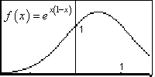
- On the TI-85, the composite function can be entered as .
Evidently it doesn’t satisfy the horizontal line test.
