CHAPTER 8 TEST C Name: _________________________
Directions: Show all work. Section: ________________________

- Which one of the following polynomials is equivalent to ?

- Observing that the graph of has intercepts at (-1,0), (0,0) and (1,0), which of the following is a graph for ?
- 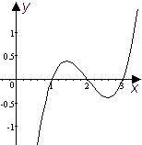 | - 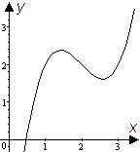 | - 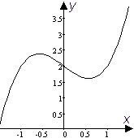
- 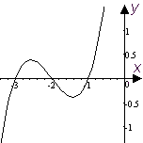 | - 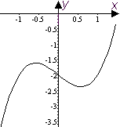 | - 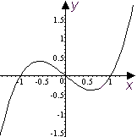

- Which one of the following rational functions has vertical asymptotes at ?

- Which one of the following fractions is equivalent to (where it is defined)?
- Which of the following is a simplification of the complex fraction ?

- Which one of the following solves for ?

- Expand and collect like terms:
- What is the coefficient of in the expansion of the product ?
- Given that , find a formula for .
- Sketch a graph of the polynomial showing, in particular, how it passes through its intercepts.
- The giant tortoise has been known to travel at speeds up to . For the various speeds in the table below, enter the time it would take a giant tortoise to travel 15 feet.
Speed (fps) | 0.05 | 0.10 | 0.15 | 0.20 | 0.25
Time (sec.)

- Reduce to lowest terms: .
- Write the product as a single fraction in lowest terms: .
- Write the quotient as a single fraction in lowest terms: .
- Observing that , completely factor the cubic: .
Hint: Use polynomial division to write , then factor Q.
- Simplify the sum as a single fraction in lowest terms: .
- Simplify the sum as a single fraction in lowest terms: .
- If two appliances with resistances a and b are connected in parallel in an electrical circuit, the combined resistance in the circuit is . If one appliance has a resistance which is 25 ohms more than the resistance of the other appliance and , find the resistances of the two appliances.
- Solve for M and simplify: .
- Find all x so that .
For problems 21-25 refer to the following:
The rational function is approximated by the interpolating polynomial
The approximation is good for , which is then considered the domain of P.
- Use a graphing utility to help make a graph for P on its domain and approximate the range to four significant digits.
- How do and compare? Describe two similarities and two differences.
- Approximate to four significant digits a solution to (other than x = 0.)
- Evaluate and .
- Use the results of #24 to find b so that has 8 real solutions.
Solutions For Chapter 8 Test Form C.

- e | - e | - d | - e | - b | - b
- .
- 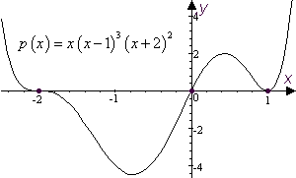

Speed (fps) | 0.05 | 0.10 | 0.15 | 0.20 | 0.25
Time (sec.) | 300 | 150 | 100 | 75 | 60

- .
- .
- .
- .
- .
- If , then . So and .
- .
- or .
- As usual, how you do this depends on what graphing calculator you use. With the TI-85, you could enter the octic polynomial and graph it as shown: 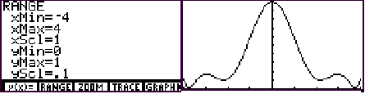
The range appears to be about
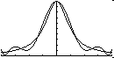
- The two graphs as shown together:
Similarities include 7 points of intersection and the fact that both functions take on only positive values. Differences include the fact that the polynomial wiggles more than the rational function and the that .
- at
- and .
- b could be any value between 0.1130 and 0.1649.

