CHAPTER 8 TEST B Name: __________________________
Directions: Show all work. Section: _________________________

- Which one of the following polynomials is equivalent to ?

- Observing that the graph of has intercepts at (-1,0), (0,0) and (1,0), which of the following is a graph for ?
- 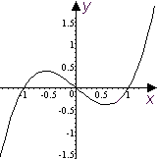 | - 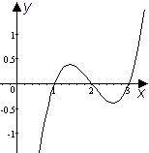 | - 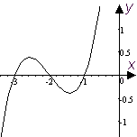
- 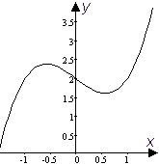 | - 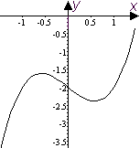 | - 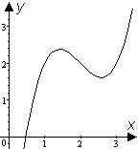

- Which one of the following rational functions has vertical asymptotes at ?

- Which one of the following is equivalent to (where it is defined)?
- Which of the following is a simplification of the complex fraction ?

- Which one of the following solves for M?

- Expand and collect like terms:
- What is the coefficient of in the expansion of the product ?
- Given that , find a formula for .
- Sketch a graph of the polynomial showing, in particular, how it passes through its intercepts.
- Wild turkeys have been known to run at speeds up to . For the various speeds in the table below, enter the time it long would it take a wild turkey to run 55 feet.
Speed (fps) | 4.4 | 8.8 | 13.2 | 17.6 | 22
Time (sec.)

- Reduce to lowest terms: .
- Write the product as a single fraction in lowest terms: .
- Write the quotient as a single fraction in lowest terms: .
- Observing that, completely factor .
Hint: Use polynomial division to write , then factor Q.
- Simplify the sum as a single fraction in lowest terms: .
- Simplify the sum as a single fraction in lowest terms: .
- If two appliances with resistances a and b are connected in parallel in an electrical circuit, the combined resistance in the circuit is . If one appliance has a resistance which is 40 ohms more than the resistance of the other appliance and , find the resistances of the two appliances.
- Solve for M and simplify: .
- Find x so that .
For problems 21-25 refer to the following:
In studying the change in enthalpy of saturated water, a cubic polynomial is fit to temperature and pressure data, approximating pressure P in terms of the temperature T:
The approximation is good for .
- Graph the polynomial on its domain and approximate the range of the function to the nearest hundredth.
- What is the pressure at boiling temperature (T = 100)?
- What temperatures produce a pressure of more than 4?
- What is the average rate of change of as T increases from 50 to 150?
- What is the average rate of change of as T increases from 90 to 110?
Solutions For Chapter 8 Test Form B.

- b | - f | - a | - c | - a | - c
- 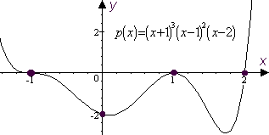
Speed (fps) | 4.4 | 8.8 | 13.2 | 17.6 | 22
Time (sec.) | 12.5 | 6.25 |  | 3.125 | 2.5

- .
- .
- .
- .
- If , then . So and .
- .
- .
- As usual, how you do this depends on what graphing calculator you use. With the TI-85, you could enter the cubic polynomial and and graph it as shown: 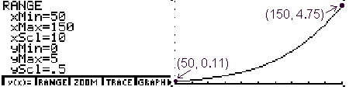
The range is approximately .
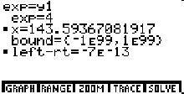
- The pressure at boiling temperature is approximately 1.00—which makes sense if you’re measuring pressure in atmospheres, which is apparently the case…
- Since P is increasing throughout its domain and (using the solver on the TI-85 as shown at right) , is true for
- The average rate of change of as T increases from 50 to 150 is .
- The average rate of change of as T increases from 90 to 110 is .

