CHAPTER 8 TEST A Name: __________________________
Directions: Show all work. Section: _________________________

- Which one of the following polynomials is equivalent to ?

- Observing that the graph of has intercepts at (-1,0), (0,0) and (1,0), which of the following is a graph for ?
- 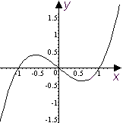 | - 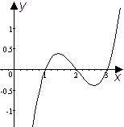 | - 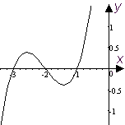
- 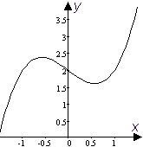 | - 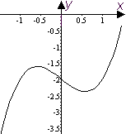 | - 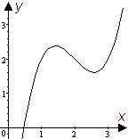

- Which one of the following rational functions has vertical asymptotes at ?

- Which one of the following is equivalent to (where it is defined)?
- Which of the following is a simplification of the complex fraction ?

- Which one of the following solves for M?

- Expand and collect like terms:
- What is the coefficient of in the expansion of the product ?
- Given that , find a formula for .
- Sketch a graph of the polynomial showing, in particular, how it passes through its intercepts.
- Grizzly bears have been known to run at speeds up to . For the various speeds in the table below, enter the time it long would it take a grizzly bear to run 100 feet.
Speed (fps) | 10 | 20 | 30 | 40 | 50
Time (sec.)

- Reduce to lowest terms: .
- Write the product as a single fraction in lowest terms: .
- Write the quotient as a single fraction in lowest terms: .
- Observing that , completely factor the cubic: .
Hint: Use polynomial division to write , then factor Q.
- Simplify the sum as a single fraction in lowest terms: .
- Simplify the sum as a single fraction in lowest terms: .
- If two appliances with resistances a and b are connected in parallel in an electrical circuit, the combined resistance in the circuit is . If one appliance has a resistance which is 45 ohms more than the resistance of the other appliance and , find the resistances of the two appliances.
- Solve for M and simplify: .
- Find x so that .
For problems 21-25 you will need a calculator and to refer to the following:
Near the summer solstice, the number of hours of daylight per day on the day of the year in Los Angeles is approximated by the quartic polynomial:
The approximation is good for
- Use a table of values with increments of 10 days to estimate the range of the function on its domain.
- Graph the polynomial on its domain.
- How many minutes of daylight are there on the summer solstice (n = 173)?
- When are the days more than 13.5 hours long?
- When are the days less than 14 hours long?
Solutions For Chapter 8 Test Form A.

- f | - b | - d | - a | - c | - c
- the coefficient is –1.
- .
- 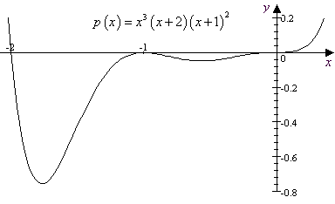
Speed (fps) | 10 | 20 | 30 | 40 | 50
Time (sec.) | 10 | 5 | 10/3 | 5/2 | 2
- .
- If , then . So and .
- As usual, how you do this depends on what graphing calculator you use. With the TI-89, you could enter the quartic polynomial and make a table of values as shown: 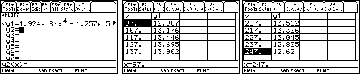
The range appears to be about
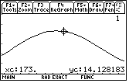
- 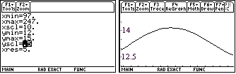
- According to this model, there are about 14.128*60 = 847.7 minutes of daylight on the summer solstice
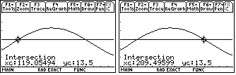
- can be solved graphically on the TI-89 as shown in the screen shots. Evidently the inequality holds for ; i.e., from April 29 to July 28.
- Using the same technique we find that . 