CHAPTER 7 TEST C Name: __________________________
Directions: Show all work. Section: _________________________

- The National Marine Fisheries Service has concluded that the population of sockeye salmon at Ozette Lake has been declining from a population of about 1000 since 1977 to the point where only about 600 fish returned to spawn in 1997. Let t represent the number of years since 1977. Which one of the following functions best describes a linear model for the population over this 20-year period?

- Which one of the following functions describes the best exponential model for the Ozette Lake sockeye salmon population (see #1) over the 20-year period?

- Which one of the following exponential functions fits the table of values below?
 |  |  | 0 | 5 | 10
 |  |  | 13 | 38.886 | 116.315

- Which one of the following logarithms is not equal to 4?

- Which one of the following expressions is equivalent to ?

- Which interval describes the domain of the function ?
- Write the logarithmic equation that is equivalent to .
- Write the exponential equation that is equivalent to .
- Evaluate
- Evaluate .
- Solve for y: .
- Solve for t: .
- Solve for k in terms of m:
- Solve for k: .
- Solve for n:
- Express in the form .
- Approximate by using the equivalent form , applying the ln function on both sides, solving for t and finally using the ln key on your calculator.
- The U.S. Fish and Wildlife Service states that in 1900, the Ohio River basin was home to 127 different species of freshwater mussel. By the year 2000, however, 11 of these mussel species were extinct. Use an exponential growth model to predict the number of such species in 2012.
Questions 19 and 20 refer to the U.S. Census Bureau statistics that report the population of Placer County, CA on 7/1/98 was 229,216 and grew to 239,485 by 7/1/99.
- Find a value of B so that the population of Placer County t years since 7/1/98 is modeled by .
- Based on this model, what will the population would Placer County be in 2048?
- Use a calculator to solve the equation accurate to the nearest hundred thousandth.
- Use a calculator to solve the equation accurate to the nearest thousandth.
- Use a calculator to complete the table with approximate values. What pattern do you observe?
1
2
3
4

- Given , use a calculator to approximate to the nearest hundredth.
- Use a calculator to approximate to the nearest hundredth. How does this compare with in problem #24 above?

Solutions For Chapter 7 Test Form C.

- c | - d | - f | - e | - c | - b
- .
- .
- .
- .
- .
- .
- Only n = 10 works.
- . So .
- Let t represent the number of years since 1900. Then So, in 2012, t = 112 and .
This may imply that 114 or 115 species survive until 2012.
- .
- In 2048, the population would be.
- 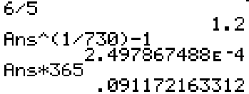
- The third column is 1 more than the second column and the fourth column is 2 more than the second column. This corresponds to the property of logarithms that .
1 | 0 | 1 | 2
2 | 0.6931 | 1.6931 | 2.6931
3 | 1.0986 | 2.0986 | 3.0986
4 | 1.3863 | 2.3863 | 3.3863

- 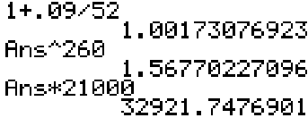

- is slightly more than

