CHAPTER 7 TEST B Name: __________________________
Directions: Show all work. Section: _________________________

- When the USA adopted the bald eagle as its national symbol in 1782, as many as 100,000 bald eagles lived in the continental United States, excluding Alaska. But by 1963, only 417 nesting pairs were found in the lower 48 States. Let t represent the number of years since 1782. Which one of the following functions best describes a linear model for the population over this 181-year period?

- Which one of the following functions describes the best exponential model for the bald eagle population (as described in #1) over the 181-year period?

- Which one of the following exponential functions fits the table of values below?
 |  |  | 0 | 3 | 6
 |  |  | 17 | 20.535 | 24.805

- Which one of the following logarithms is not equal to 2?

- Which one of the following expressions is equivalent to ?

- Which interval describes the domain of the function ?
- Write the logarithmic equation that is equivalent to .
- Write the exponential equation that is equivalent to .
- Evaluate .
- Evaluate .
- Solve for t: .
- Solve for P: .
- Solve for t in terms of x: .
- Solve for r: .
- Solve for d:
- Express in the form .
- Approximate by using the equivalent form , applying the ln function on both sides, solving for x and finally using the ln key on your calculator.

- The Michigan Department of Natural Resources reports that, by 1971, the population of Kirtland’s warbler had plummeted to about 400 birds (200 nesting pairs.) At that time, biologists began counting singing male warblers every year. In 1996, 629 singing males were counted. Use an exponential growth model to predict the population in 2000.
Questions 19 and 20 refer to the U.S. Census Bureau statistics that report the population of Riverside County, CA on 7/1/98 was 1,480,708 and grew to 1,530,653 by 7/1/99.
- Find a value of b so that the population of Riverside County t years since 7/1/98 is modeled by .
- Based on this model, what population would Riverside County have had on 7/1/97?
- Approximate the solution to the equation to the nearest thousandth.
- Approximate the solution to the equation to the nearest thousandth.
- Use a calculator to complete the table. What pattern(s) do you observe?
687
787
887
987

- Given , use a calculator to approximate to the nearest hundredth.
- Use a calculator to approximate to the nearest hundredth. How does this compare with in problem #24 above?

Solutions For Chapter 7 Test Form B.

- d | - e | - e | - b | - d | - e
- .
- .
- .
- .
- .
- .
- .
- . Only d = 3 works.
- .
So
- .
- Let t represent the number of years since 1971. Then the population of nesting pairs is In year 2000, t = 29 and .
- .
- In 1997, the population would’ve been.
- or
- 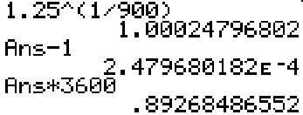
- The third column is 1 less than the second column and the fourth column is 2 less than the second column. This corresponds to the property of logarithms that .
687 | 2.8370 | 1.8370 | 0.8370
787 | 2.8960 | 1.8960 | 0.8960
887 | 2.9479 | 1.9479 | 0.9479
987 | 2.9943 | 1.9943 | 0.9943
- 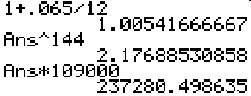

- is slightly more than

