CHAPTER 5 TEST C Name: __________________________
Directions: Show all work. Section: _________________________

- Which one of the following functions fits this table of values?
 |  |  | 0 |  | 2 | 3

- If , then

- Which of the following graphs represents y as a function of R?
- 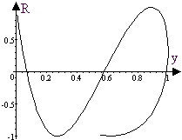 | - 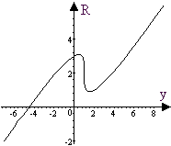
- 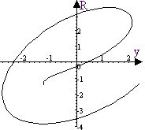 | - 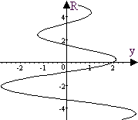
- Which one of the intervals describes the range for ?

- Which one of the following is true about the table?
 | 0 | 1 | 2 | 3
 | 1 | 2 | 3 | 4
  - The variable y varies inversely with x.
  - The variable y varies directly with x.
  - The variable y varies inversely with the square of x,
  - The variable y varies directly with the square of x.
  - None of the above.

- The Center for Agricultural and Rural Development (CARD) has studied methods of reducing emissions of greenhouse gases involved in farming. For instance, the graph below models the expected annual cost, P (in $ per ton) of sequestering c tons of carbons in agricultural soils. Which one of the following functions best fits the graph?
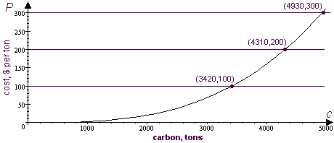
Questions 7-9 refer to the graph shown below, which describes fuel costs
(in 1998 cents/mile) over the years from 1970 to 2000.
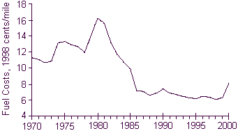
- Estimate the maximum and minimum fuel costs in 1998 cents/mile. In what years did these extreme costs occur?
- Does the graph show fuel cost to be a function of time? Justify your answer.

- Estimate the rate of change of fuel cost per year over the years from 1978 to 1980.

Problems 10-12 refer to the table at the right that tabulates the taxes in 1999 for annual incomes up to $124.99.
Income | Tax
$0 -- $4.99 | $0
$5 -- $14.99 | $2
$15 -- $24.99 | $3
$25 -- $49.99 | $6
$50 -- $74.99 | $9
$75 -- $99.99 | $13
$100 -- $124.99 | $17

- Explain why I, income, is not a function of T, the tax owed on that income, but the tax is a function of income.

- What is the value of ?

- According to this table, what is the highest possible tax rate?

- Alma skates 100 meters across a frozen pond at a constant rate of 2.5 meters per second. Write a function that gives the distance D skated as a function of the time t she skates. What is the domain of your function in this context?

Questions 14-16 refer to the table below showing the mass density d of a gas occupying a sphere of radius r. In this situation, d is inversely proportionate to the cube of r.
 | 5 | 10 | 12
 | 10.240 | 1.280 | 0.741

- Compute the products of the density and the cube of the radius . What is the constant of proportionality?
- Express the gas density d as a function of the sphere radius r.
- Sketch a graph of the function . Remember to show a scale on each axis.
Problems 17-19 refer to the function whose graph is shown below.
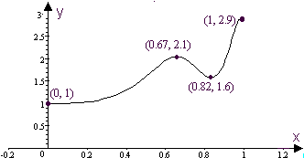
- What are the domain and range of the function?
- Over what interval(s) is the function decreasing?
- What range of output values each correspond to three distinct input values?

- The total power P produced by a hydroelectric power plant (measured in Kilowatts) is a function of the turbine’s efficiency, E. If P is directly proportional to E and , find a formula for .
- Complete the table of values for the function . Round to three digits, if needed.

- Complete the table of values for the function . Approximate to three significant digits.

- Use a calculator to help make a graph of the function for . Scale your axes and label coordinates of at least 3 points on the graph.

- Use a calculator to help make a graph of the function for . Scale your axes and label coordinates of 3 points on the graph.
- Use a calculator to help make a graph of the function for . Scale your axes and label coordinates of 3 points on the graph.
Solutions For Chapter 5 Test Form C.

- f | - a | - d | - c | - e | - c
- A maximum cost of 16 1998 cents/mile occurred in 1980, and the minimum cost of 6 1998 cents/mile occurred in 1998.
- Yes. The graph satisfies the vertical line test, so fuel cost is a function of time.
- is the rate of change over this time period.
- Since a single tax corresponds to a whole range of incomes, I, income is not a function of T, the tax owed on that income. One the other hand, for any amount of income, there is a single amount of tax owed.
- The highest tax rate is 40%, for someone earning $5.
- Measuring in meters,. The function will have a domain
- The constant of proportionality is 1280.
- 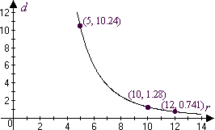
- Domain is [0,1] and range is [1,2.9].
- Decreasing on (0.67, 0.82).
- Outputs in (1.6,2.1).
- 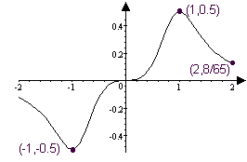
- 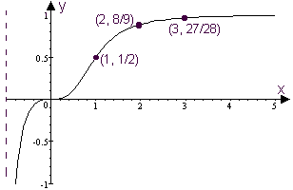
25. 