CHAPTER 5 TEST B Name: __________________________
Directions: Show all work. Section: _________________________

- Which one of the following functions fits this table of values?
 |  |  | 0 |  | 2 | 3

- If , then

- Which of the following graphs represents p as a function of t?
- 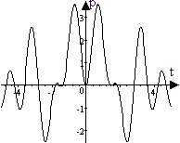 | - 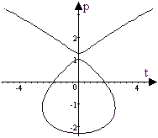
- 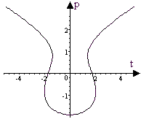 | - 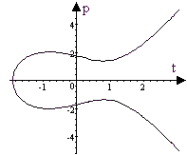
- Which one of the intervals describes the range for ?
- Which one of the following is true about the table?
 | 0 | 2 | 5 | 10
 | 0 | 12 | 75 | 300
  - The variable y varies inversely with x.
  - The variable y varies directly with x.
  - The variable y varies inversely with the square of x,
  - The variable y varies directly with the square of x.
  - None of the above.

- The graph below models A, the number of acres of forest “in fuel condition” over a 100-year period, under one forest management scenario.
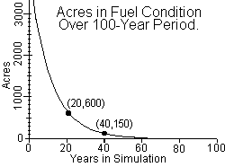
Which one of the following function formulas best describes A as a function of t?
Questions 7-9 refer to the graph shown below, which describes the amount of global greenhouse gas emissions (ghg,) as a portion of a fuel economy of 20 miles per gallon, in terms of fuel economies ranging up to 80 miles per gallon (mpg.)
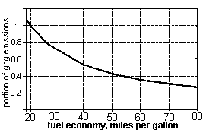
- Estimate the rate of change in ghg emissions per mpg as mpg increases from 20mpg to 40mpg.
- Does the graph show greenhouse gas emission (ghg) to be a function of fuel economy? Justify your answer.

- Does the graph show mpg to be a function of ghg emission? Justify your answer.
Problems 10-12 refer to postal rates in Canada and Mexico, as tabulated below in US $.
W  Weight (oz) | C Canadian rate | M  Mexican rate
Up to 0.5 | $0.48 | $0.40
0.51 – 1.0 | 0.55 | 0.46
1.01 – 1.5 | 0.67 | 0.66
1.51 – 2.0 | 0.76 | 0.86
2.01 – 3.0 | 1.00 | 1.26
3.01 – 4.0 | 1.20 | 1.66
4.01 – 5.0 | 1.40 | 2.06
- Explain why both C, the Canadian rate, and M, the Mexican rate, are functions of W, but W is neither a function of C nor a function of M.

- What is the value of ?

- Is the rate of change of either the Canadian or the Mexican postal rates per ounce linear? Explain.

- Martin bicycles 200 yards once around a track, cycling at a constant rate of 4.0 feet per second. Write a function formula giving the distance D cycled as a function of the time t he cycles. What is the domain of your function in this context?

Questions 14-16 refer to the table below which shows the intensity of sound I from a foghorn as inversely proportional to the square of the distance from the foghorn.
 | 0.5 | 1 | 2
I | 100528 | 25132 | 6283

- Compute the products of the square of the distance and the sound intensity I. What is the constant of proportionality?
- Express the intensity of sound I as a function of its distance d from the foghorn.
- Sketch a graph of the function . Be careful to show a scale on each axis.
Problems 17-19 refer to the function whose graph is shown below.
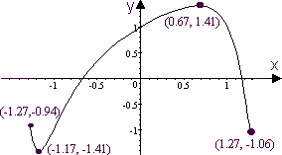

- What are the domain and range of the function?
- Over what interval(s) is the function increasing?
- Approximate the input value(s) for which the output is 0.

- The power P produced by a coal burning power plant (measured in Megawatts) is a function of the amount of anthracite A burned (measured in thousands of tons.)
If P is directly proportional to A and , find a formula for .
- Complete the table of values for the function . Approximate to three digits, if necessary.

- Complete the table of values for the function . Approximate to three significant digits.

- Use a calculator to help make a graph of the function for . Scale your axes and label coordinates of at least 3 points on the graph.

- Use a calculator to help make a graph of the function for . Scale your axes and label coordinates of at least 3 points on the graph.
- Use a calculator to help make a graph of the function for . Scale your axes and label coordinates of 3 points on the graph.
Solutions For Chapter 5 Test Form B.

- b | - e | - a | - e | - d | - c
- The rate of change is approximately .
- Yes, since the graph satisfies the vertical line test, it shows portion of ghg to be a function of fuel economy in mpg.
- Yes, the graph also passes the horizontal line test, so the portion of ghg emission of also a function of the fuel economy in mpg.
- W is a function of neither C nor M since, for instance, a postal rate of $0.67 corresponds to any weight between 1 and 1.5 ounces. However, for a given weight in a given country there will be only one postal rate.
- Neither C nor M is a linear function of W. The rate of change of M for instance is initially $0.12/oz and then increases to $0.4/oz, while the W initially increases at $0.14/oz and then at $0.2/oz.
- Measuring in feet,. The function will have a domain .
 | 0.5 | 1 | 2
I | 100528 | 25132 | 6283
- The constant of proportionality is 25132
- 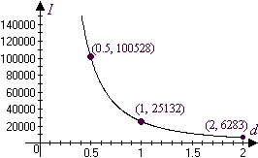
- Domain = [-1.27,1.27]; range = [-1.41,1.41]
- Increasing on the interval [-1.17, 0.67].
- near t = -0.67 and 1.17.
- 
 