CHAPTER 5 TEST A Name: __________________________
Directions: Show all work. Section: _________________________

- Which one of the following functions fits this table of values?
 |  |  | 0 |  | 2 | 3

- If , then

- Which of the following graphs represents A as a function of w?
- 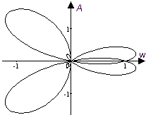 | - 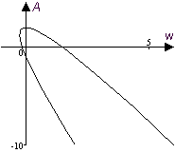
- 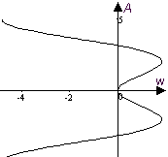 | - 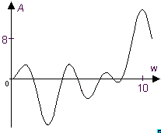
- Which one of the intervals describes the range for ?

- Which one of the following is true about the table?
 | 0 | 3 | 6 | 7
 | 0 | 2 | 4
  - The variable y varies inversely with x.
  - The variable y varies directly with x.
  - The variable y varies inversely with the square of x,
  - The variable y varies directly with the square of x.
  - None of the above.

- The graph below describes the amount of nitrogen per tree (measured in grams) in relation to the density of trees in the forest (measured in 1000’s of trees per hectare.) 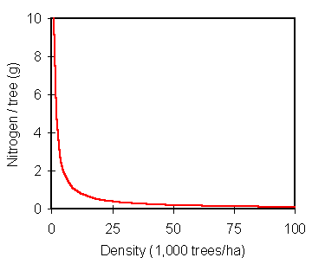
Which one of the following function formulas best describes the nitrogen per tree, N, as a function of tree density in the forest, D?
Questions 7-9 refer to the graph shown below, which describes fuel efficiency (in miles per gallon) in relation to speed for a typical compact car.
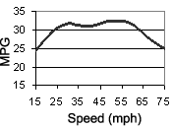
- Estimate the range of speeds that yield the greatest fuel economy.
- Does the graph show fuel efficiency to be a function of speed? Justify your answer.

- Does the graph show speed to be a function of fuel efficiency? Justify your answer.

Problems 10-12 refer to the table at the right that tabulates the shipping costs for ordering candy.
Merchandise Cost (M) | Shipping Charge (C)
Up to $19.99 | $7.50
$20 - $34.99 | 10.5
$35 - $49.99 | 11.5
$50 - $74.99 | 12.5
$75 - $89.99 | 13.5
$90 - $119.99 | 15
$120 - $249.00 | 19
$250 and over | 8% of net

- Explain why the merchandise cost, M, is not a function of the shipping charge, C, but C is a function of M.

- What is the value of ?

- What is the value of ?

- Marla starts at one end of a field and walks 100 yards to the other end of the field, walking at a constant rate of 3.2 feet per second. Write a function formula that gives the distance D she’s walked as a function of the time t she walks. Considering the particular application, what is the domain of your function?

Questions 14-16 refer to the table, which shows the distance d of an object from a light, and the corresponding height h of a shadow the object casts on a wall. In this situation, h is inversely proportionate to d.
 | 0.5 | 1 | 2
 | 20 | 10 | 5

- Compute the products of the distance, d, and the height, h. What is the constant of proportionality?
- Express the height of the shadow h as a function of its distance d from the light.
- Sketch a graph of the function . Remember to show a scale on each axis.
Problems 17-19 refer to the function whose graph is shown below.
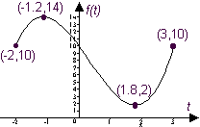
- What are the domain and range of the function?
- What is the minimum value of the function?
- For what input values is the output equal to 10?

- The total power P produced by a plant through photosynthesis (measured in watts) is a function of the plant’s total leafy surface area, A (measured in square meters.) If P is directly proportional to A and , find a formula for .
- Complete the table of values for the function . Approximate to three digits, if necessary.

- Complete the table of values for the function . Approximate to three significant digits.

- Use a calculator to help make a graph of the function for . Scale your axes and label coordinates of 3 points on the graph.

- Use a calculator to help make a graph of the function for . Scale your axes and label coordinates of 3 points on the graph.
- Use a calculator to help make a graph of the function for . Scale your axes and label coordinates of 3 points on the graph.
Solutions For Chapter 5 Test Form A.

- c | - b | - d | - e | - b | - b
- Speeds between approximately 47mph and 56mph produce the greatest fuel economy, according to the graph.
- Yes, since the graph satisfies the vertical line test, it shows fuel economy to be a function of speed.
- No, speed is not a function of fuel economy. For example, 25 mpg corresponds to both 16 mph and 75 mph.
- M is not a function of C since, for instance, a shipping of cost of $7.50 corresponds to any order of merchandise less than $20. However, for a given order there will be only one shipping cost.
- Measuring in feet,. The function will have a domain
- The constant of proportionality is 10.
- 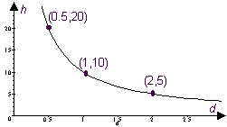
  - Domain is [-2,3] and range is [2,14].
  - The minimum value of the function is 2.
  - for t = -2,0 and 3.
- 
 