CHAPTER 4 TEST B Name: ___________________________
Directions: Show all work. Section: __________________________

- Which one of the following graphs represents
- 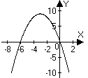 | - 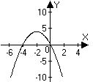 | - 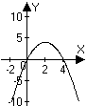
- 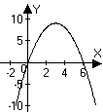 | - 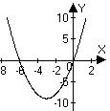 | - 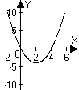
- Which one of the following equations has intercepts at ?

- Which one of the following gives an equation for the parabola shown?
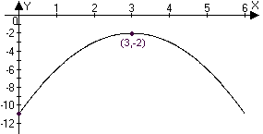

- The parabola whose coefficients fit the system of equations at right contains which one of the following sets of points?
- Which one of the following results from combining equations in the system below?

- Which of the following intervals gives the solution to the inequality ?

For problems 7-10, find the coordinates of the intercepts and the vertex of the parabola whose equation is given, then sketch a graph.

In problems 11-13, write an equation for the parabola passing through the given point and having its vertex at . Also, sketch a graph for each showing the coordinates of all intercepts for each.

- Solve the system of equations algebraically and verify your solutions with a graph.

- Solve the inequality: . Write the solution in interval notation.

- Solve the inequality: . Write the solution in interval notation.

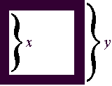
- The area of a square picture frame is found by subtracting the area of the inner square from the area of the outer square (see the diagram at right.) Show that if the edge of the outer square is 5 less than 2 times the edge of the inner square, then the area of the frame is .

- Find exact values for x and y to produce a frame of area 4 in problem #17. Simplify the radicals in your expressions for x and y.

- The sum of twice one number and three times another number is 5. Find two such numbers so to maximize their product.

- Salt water is entering a tank full of water at the same time that the water is draining out of the tank. The water is draining out of the tank at a faster rate than the water is coming in so that the total amount of salt in the tank, S, (measured in grams) at time t (measured in hours) is given by the quadratic equation, . After how many hours is the amount of salt in the tank at a maximum?

- Approximate the positive solution to to the nearest hundredth.

- Use a calculator to approximate the solution interval to where r is positive. Round to the nearest hundredth in the solution interval.
- Approximate the x-intercepts of the parabola described by .

For problems 24 and 25, use the Chesapeake Bay temperature data tabulated at right.
Temperature data for the years 1986 - 1990 taken from the middle of the Bay mouth (degrees Celsius)
Month | 1986 | 1987 | 1988 | 1989 | 1990
Jan. | 5.28 | 5.52 | 1.56 | 5.76 | 5.28
Feb. | 3.72 | 3.60 | 4.68 | 5.28 | 7.20
Mar. | 5.76 | 5.28 | 7.20 | 5.88 | 9.72
April | 10.90 | 9.84 | 11.40 | 11.50 | 12.50
May | 15.80 | 17.60 | 17.30 | 16.70 | 18.40
June | 21.60 | 20.40 | 21.80 | 22.50 | 21.20
July | 25.60 | 24.40 | 24.70 | 26.00 | 25.10
Aug. | 25.10 | 25.90 | 22.80 | 25.10 | 26.30
Sept. | 22.40 | 24.40 | 21.60 | 22.70 | 24.00
Oct. | 20.00 | 16.90 | 18.00 | 18.20 | 21.10
Nov. | 13.40 | 12.60 | 12.80 | 13.60 | 13.00
Dec. | 9.36 | 6.96 | 9.72 | 7.70 | 8.64

- Use linear regression to find the best linear fit for the temperature during April in terms of the number of years since 1985.

- Use quadratic regression to find the best quadratic fit for the temperature during 1989 in terms of the number of months since the beginning of the year.
Solutions For Chapter 4 Test Form B.

- b | - e | - b | - b | - f | - c
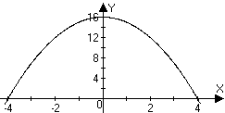
- The intercepts of are .
The vertex is at .
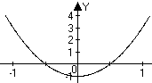
- The intercepts of are Vertex at .
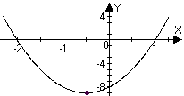
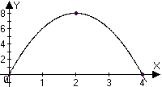
- The intercepts of are . Vertex at .

- The intercepts of are . The vertex is at .

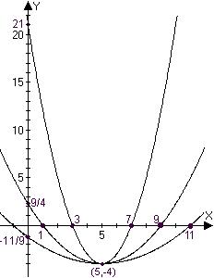
- Plugging into , yields , so is an equation for the parabola with intercepts at .
- Plugging in , , so is an equation for the parabola with intercepts at .

- At , , so is an equation for the parabola with intercepts at
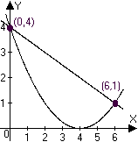
- Substituting into we have
This is equivalent to Computing the corresponding y-values, we find solutions at and , as shown:
- .
- so .
- Substituting into , we have
- . But if , then , which isn’t possible. Thus and .
- Let represent the two numbers. Then so that the product is . This is maximized where . Thus the numbers we seek are and .
- is maximized where
- and if .
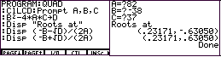
- . At right is shown how a TI-85 program used to approximate the roots. Note that the discriminant , D, is computed. The roots are.
- The screen shots below show how the linear regression can be carried out on a TI-85. This process varies quite a bit from calculator to calculator. The second screen is interpreted to show the regression line is . 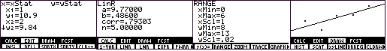
- Screen shots for quadratic regression are shown below. The regression parabola fitting temperature to time (in months) is .
