CHAPTER 4 TEST A Name: ___________________________
Directions: Show all work. Section: __________________________

- Which one of the following graphs represents
- 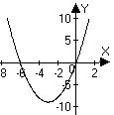 | - 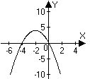 | - 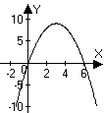
- 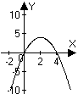 | - 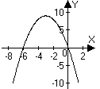 | - 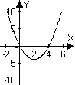

- Which one of the following equations has intercepts at ?

- Which one of the following gives an equation for the parabola shown?
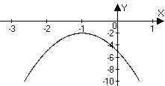
- The parabola whose coefficients fit the system of equations at right contains which one of the following sets of points?

- Which one of the following equations results from combining the equations in the system ?

- Which of the following intervals gives the solution to the inequality ?

For problems 7-10, find the coordinates of the intercepts and the vertex of the parabola whose equation is given, then sketch a graph.

In problems 11-13, write an equation for the parabola with x-intercepts at which also passes through the given point. Sketch a graph for each.

- Solve the system of equations algebraically and verify your solutions with a graph.

- Solve the inequality: . Write the solution in interval notation.

- Solve the inequality: . Write the solution in interval notation.

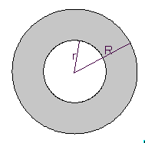
- The area of an annulus is found by subtracting the area of the inner circle from the area of the outer circle: . (See the diagram at right.) Show that if the radius of the outer circle is 1 more than 2 times the radius of the inner circle, then the area of the annulus is .

- Find exact values for r and R in problem #17 to produce an annulus of area 4. Simplify the radicals in your expressions.

- The difference of twice one number and three times another number is 24. Find two such numbers so to minimize their product.

- Salt water is entering a tank full of water at the same time that the water is draining out of the tank. The water is draining out of the tank at a faster rate than the water is coming in so that the total amount of salt in the tank, S, (measured in grams) at time t (measured in hours) is given by the quadratic equation, . After how many hours is the amount of salt in the tank at a maximum?

- Use a calculator to approximate the positive solution for, accurate to the nearest thousandth.

- Use a calculator to approximate the solution interval to where r is positive. Round to the nearest thousandth included in the interval.

- Approximate the x-intercepts of the parabola described by

For problems 24 and 25, use the Chesapeake Bay temperature data tabulated at right.
Temperature data for the years 1986 - 1990 taken from the middle of the Bay mouth (degrees Celsius)
Month | 1986 | 1987 | 1988 | 1989 | 1990
Jan. | 5.28 | 5.52 | 1.56 | 5.76 | 5.28
Feb. | 3.72 | 3.60 | 4.68 | 5.28 | 7.20
Mar. | 5.76 | 5.28 | 7.20 | 5.88 | 9.72
April | 10.90 | 9.84 | 11.40 | 11.50 | 12.50
May | 15.80 | 17.60 | 17.30 | 16.70 | 18.40
June | 21.60 | 20.40 | 21.80 | 22.50 | 21.20
July | 25.60 | 24.40 | 24.70 | 26.00 | 25.10
Aug. | 25.10 | 25.90 | 22.80 | 25.10 | 26.30
Sept. | 22.40 | 24.40 | 21.60 | 22.70 | 24.00
Oct. | 20.00 | 16.90 | 18.00 | 18.20 | 21.10
Nov. | 13.40 | 12.60 | 12.80 | 13.60 | 13.00
Dec. | 9.36 | 6.96 | 9.72 | 7.70 | 8.64

- Use linear regression to find the best linear fit for the temperature during May in terms of the number of years since 1985.

- Use quadratic regression to find the best quadratic fit for the temperature during 1990 in terms of the number of months since the beginning of the year.
Solutions For Chapter 4 Test Form A.
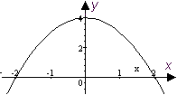
- d | - a | - d | - e | - e | - b

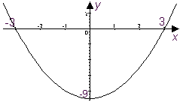
- The intercepts of are . The vertex is at .

- The intercepts of are The vertex is at .
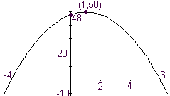

- The intercepts of are The vertex is at .
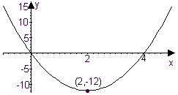
- The intercepts of are . The vertex is at .

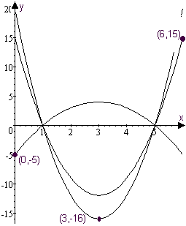
- Plugging into , we have , so is an equation for the parabola.
- Plugging into , we have , so is an equation for the parabola.
- Plugging into , we have , so is an equation for the parabola.
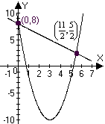
- Substituting into we have . This is equivalent to Computing the y-values, we find solutions at and , as shown:
- .
- Substituting into , we have
- Let represent the two numbers. Then so that the product is . This is minimized where . Thus the numbers we seek are and 6.
- is maximized where
- (see #18.)
- and if (see #21.)
- if . Here’s how this might work on a calculator (note that the discriminant, D, is computed): 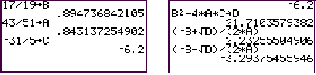
- The screen shots below show how the linear regression can be carried out on a TI-85. This process varies quite a bit from calculator to calculator. The second screen is interpreted to show the regression line is 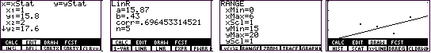
- Screen shots for quadratic regression are shown below. The regression parabola fitting temperature to time (in months) is
