CHAPTER 3 TEST C Name: __________________________
Directions: Show all work. Section: _________________________

- Which of the following is a complete factorization of

- Which of the following equations has solutions at

- Which one of the following gives both solutions to the equation

- Which one of the following should be added to to complete the square?

- Which of the following quadratic equations has a negative discriminant?

- Which one of the following equations has a solution at

- Expand the product completely and collect like terms.

- Factor completely:

- Factor completely: .

- Find both solutions for , write your solutions in exact form.

- Solve the equation by factoring: .

- A stone is thrown upward off a cliff so that its height above the cliff’s edge after
t seconds is given by , where h is measured in feet. How long will it take for the stone to drop 35 feet below the edge of the cliff?
- Find an equivalent equation with the square complete: .

- Find the equivalent equation with the square complete: .

- Find solutions for . Write the solutions in simplest radical form.
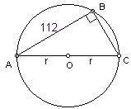
- Solve for r.

- In the diagram at right, is a right triangle with diameter AC and right angle at B. Find the radius r if AB = 112 and . That is, BC is one more than the radius.

- If the long leg of a right triangle is 11 feet less than twice the short leg and the hypotenuse is 3 feet less than twice the short leg, what are the lengths of the legs?

- The hypotenuse of a right triangle is 10 more than three times the short leg. If the square of the longer leg is 912, what is the length of the hypotenuse?

- Use the quadratic formula to solve for n in terms of x: .

- Use a calculator to approximate two values for to the nearest hundredth.

- Use a calculator to approximate the maximum value of .

- Use your calculator to approximate the complex roots of .
- Use your calculator to complete the table of values of the equation with approximations: .

- Use a calculator to graph fit to x in the interval. Sketch a graph showing approximate values for the intercepts. Describe the shape by analogy with another well-known shape.
Solutions For Chapter 3 Test Form C.
- b | - e | - f | - a | - e | - c
- .
- .
- The stone is 35ft down when ; that is, after 5 seconds.
- .
- .
- .
- .
Or, .
- Or, .
In either case, since ,
- Let x = the length of the short leg (in feet). Then the length of the longer leg is and the hypotenuse is . Pythagoras’ theorem yields . If x = 4, then the length of the long leg would be negative, so it seems that is the length of the short leg and is the length of the long leg.
- Let x = the length of the short leg. Then . So the length of the shorter leg is 7 and the length of the hypotenuse is 3(7) + 10 = 31.
- or .
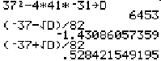
- As the screen shot at right shows, one way to approach these approximations is to first compute the discriminant and store it in variable name D. Then each approximation is simpler. Either or .
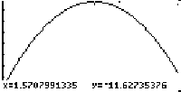
- We know that the max will occur at . Using the “ZFIT” zoom over and the “FMAX” feature on the math submenu of the graph menu on the TI-85, we find the maximum value is
- has zeros at .
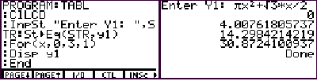
- One way to approximate the function values is to write a little TI-85 program that will do the trick, as shown at right: .

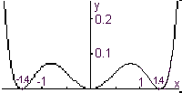
- The intercepts are at and . The shape is toothy like a partly drawn curtain.

