CHAPTER 3 TEST B Name: ______________________
Directions: Show all work. Section: _____________________

- Which one of the following is a complete factorization of

- Which one of the following equations has solutions at

- Which one of the following gives both solutions to the equation

- Which one of the following should be added to to complete the square?

- Which of the following quadratic equations has a negative discriminant?

- Which one of the following equations has a solution at

- Expand the product completely and collect like terms.

- Factor completely:

- Factor completely: .

- Find both solutions for , write your solutions in exact form.

- Solve the equation by factoring: .

- A stone is thrown upward so that its height h after t seconds is given by , where h is measured in feet. When will the stone reach its maximum height? What is this maximum height?
- Find the equivalent equation with the square complete: .

- Find the equivalent equation with the square complete: .

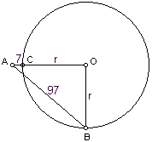
- Find solutions for . Write the solutions in simplest radical form.

- Solve for p.

- In the diagram at right, is a right triangle with right angle at the circle’s center, O. Find the radius r of the circle if AC = 7 and AB = 97.

- If the longer leg of a right triangle is 1 foot less than four times the short leg and the hypotenuse is 1 foot longer than four times the shorter leg, what are the lengths of the legs?

- The hypotenuse of a right triangle is 13 less than three times the shorter leg. If the square of the longer leg is 189, what is the length of the hypotenuse?

- Use the quadratic formula to solve for k in terms of n: .

- Use a calculator to approximate both values for , accurate to the nearest hundredth place.

- Use a calculator to approximate the maximum value of , accurate to the nearest hundredth place.

- Use your calculator to approximate the complex roots of , accurate to the nearest hundredth place.
- Use your calculator to complete the table of values of the equation with approximations: .

- Use a calculator to graph in the standard window. Sketch a graph showing approximate values for the intercepts.
Solutions For Chapter 3 Test Form B.
- c | - b | - a | - c | - d | - f
- The height has a maximum value of 55 when t = 7/4 = 1.75 seconds.
- .
- .
- .
- .
- Since the radius must be positive,
- Let x = the length of the shorter leg (in feet). Then the length of the longer leg is , the length of the hypotenuse is and Pythagorus’ theorem yields , so that the shorter leg has length 16 feet and the longer leg has length 63 feet.
- Let x = short leg length. Then
So the hypotenuse is 3(10)-13 = 17.
- . So either or .
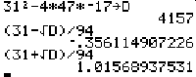
- As the screen shot at right shows, one way to approach these approximations is to first compute the discriminant and store it in variable name D. Then each approximation is simpler. Either or .
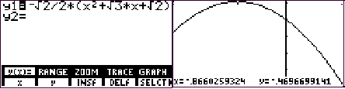
- We know that the max will occur at . This is supported by the graph shown in the standard window at right below. Using the “FMAX” feature on the math submenu of the graph menu on the TI-85, we find the maximum value is
- has roots at
- One way to approximate the function values is to use the “seq” syntax to form a sequence on the TI-85. The decimal mode is set fixed to 2 for ease in viewing.
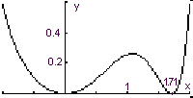
- The intercepts are at and . The shape is looks like the profile of some wooden sandals.

