CHAPTER 3 TEST A Name: __________________________
Directions: Show all work. Section: _________________________

- Which one of the following is a complete factorization of

- Which one of the following equations has solutions at

- Which one of the following gives both solutions to the equation

- Which one of the following should be added to to complete the square?

- Which of the following quadratic equations has a negative discriminant?

- Which one of the following equations has a solution at

- Write the product as a polynomial in descending powers’ form.

- Factor completely:

- Factor completely: .

- Find both solutions for , write your solutions in exact form.

- Solve the equation by factoring: .

- A stone is thrown downward off a cliff so that the distance it has traveled after t seconds is given by , where d is measured in feet. How long will it take the stone to travel 144 feet?
- Find the equivalent equation after completing the square: .

- Find the equivalent equation after completing the square: .

- Find solutions for . Write the solutions in simplest radical form.

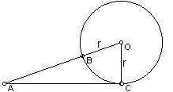
- Solve for t.

- In the diagram at right, is a right triangle with right angle at C. Solve for r if AC = 12 and AB = 8.

- If one leg of a right triangle is 7 feet longer than the other leg and the hypotenuse is 17 feet, what are the lengths of the legs?

- One leg of a right triangle is 7 more than twice the other leg. If the square of the hypotenuse is 706, what are the lengths of the two legs?

- Solve for y in terms of x: . Use the quadratic formula.

- Use a calculator to approximate

- Use a calculator to approximate the maximum value of .

- Use your calculator to approximate the complex roots of .
- Use your calculator to complete the table of values of the equation with approximations:

- Use a calculator to graph in the standard window. Sketch a graph showing approximate values for the intercepts. In what way(s) does this graph resemble a parabola?
Solutions For Chapter 3 Test Form A.
- c | - d | - e | - a | - d | - b
- Let x = the length of the shorter leg (in feet). Then the length of the longer leg is and Pythagoras’ theorem yields
- =
- We know that the max will occur at . This is supported by the graph shown in the standard window at right below. Using the “EVAL” feature on the graph menu we find the maximum value is 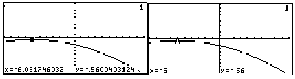
- has roots at
- One way to approximate the function values is to enter it on the graph page and then evaluate it on the home page, as shown below. . 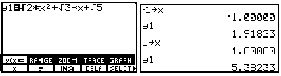
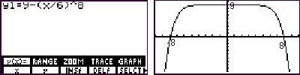
- It looks like a parabola in that it has bilateral symmetry and it’s U-shaped, but it’s flatter on the top and on the sides than a parabola.

