CHAPTER 2 TEST C Name: __________________________
Directions: Show all work. Section: _________________________

- Which of the following is the solution to the system of equations: ?
- Which graph best illustrates the solution to the system of equations: ?
- 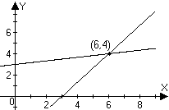 | - 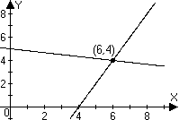
- 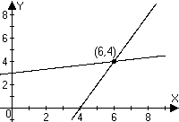 | - 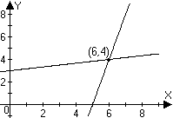

- Which one of the following systems of equations is inconsistent?

- Which one of the following systems of equations is consistent and not dependent?

- Which one of the following systems of equations is dependent?

- Which of the following is not an elementary row operation?
  - Interchange the first and last rows.
  - Multiply the last row by zero.
  - Add the first row to the last row.
  - Divide the entries of the first row by 15.
  - Subtract the second row from the last row.
- Solve the system of equations by using a graph. Give coordinates of the solution.
- A sidewalk vendor sells two types of sunglasses: he sells polarized glass sunglasses for $7.90 each and polarized polycarbonate sunglasses for $9.90 each. The vendor earned $271 revenue selling at total of 30 sunglasses during a day. Set up a system of two equations in two unknowns and solve the system to determine how many polarized polycarbonate sunglasses he sold.
- Solve the system by substitution.
- Solve the system by using elimination.
- A telephone bill totals $73.20 for basic service charges and long distance charges. If the basic service charges are $32.78 more than the long distance charges, how much of the bill was for basic service? Use algebra to solve the problem.

- A collection of 25 marbles includes marbles of three different sizes. Small marbles occupy 0.15 cubic centimeters () of volume, medium sized marbles are and large marbles are . The total volume of the marble collection is . There are two more large marbles than there are small marbles. Set up and solve a system of equations to find how many of each type of marble there are in the collection.

- Solve the system by back substitution:

- Find a solution the system (in x, y and z) with the augmented matrix:
- Use matrix reduction to solve the system:

- Solve the system using Gaussian elimination on an augmented matrix:
- Write a sequence of row equivalent augmented matrices to achieve an upper triangular matrix and then use back substitution to solve the system:

- The sum of the interior angles in any quadrilateral is . In quadrilateral ABCD, is a , is less than the sum of and , and is three times . Find the degree measure of each angle.
- Graph the system of inequalities, label the vertices with coordinate values and shade the solution region:
- Consider the problem of optimizing P = 50x + 80y
subject to the constraints:
  - Make a graph illustrating the region where the constraint system is satisfied.
  - Find the coordinates of the vertices for this feasible region.
  - Find the maximum and minimum values of P satisfying the constraints.

- Use a calculator to find exact values for the solution of the system.
- Use a calculator to write the augmented matrix for the system in problem #21 in upper triangular (row-echelon) form.

- Use a calculator to solve the system with the augmented matrix.

- Use a calculator to solve the system of equations.
- Use a calculator to find the row echelon form of the augmented matrix associated with problem #24. Write entries either as decimals or fractions.
Solutions For Chapter 2 Test Form C.
- a | - a | - d | - b | - a | - b
- 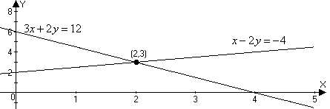
- Let G represent the number of polarized glass sunglasses sold and let P represent the number of polarized polycarbonate sunglasses sold. Then and . Substituting into the first equation we have polarized polycarbonate sunglasses were sold.
- and .
- Eliminating y, we get & . So .
- Let B = the bill for basic service, then the bill for long distance is B – 32.78, and the total cost is is the basic service charge.
- Let S = number of small marbles, M = number of medium sized marbles and L = number of large marbles. Then . Thus
- . Thus, .
- So
- Let A =, B =, etc. Then and . Substituting for B,
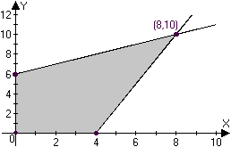
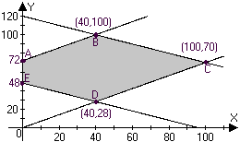
- The maximum value of P is 10600 at (100,70) and the minimum is 3840 at (0,48).
- Using “SIMULT” on the TI-85, we have find that and : 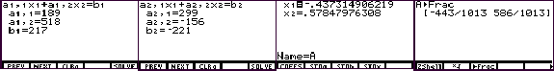

- As the screen shots below show, on the TI-85, you can enter the matrix and store it to A. Then use the “ref” command on A to convert it to row-echelon form. Converting to fractions, we see that the row-echelon form for the augmented matrix is 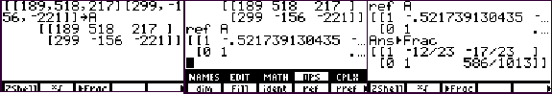

- Using the “rref” command to perform row operations that transform the augmented matrix to reduced row echelon form, we see that : 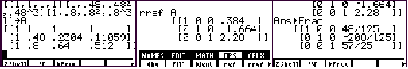
- Again, using “rref” on the augmented matrix can solve the system. Evidently, the solution is Note that is a floating point error. 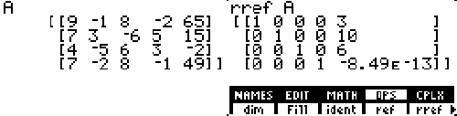
- Using the “ref” command gives upper triangular form: 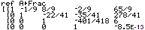 or .

