CHAPTER 2 TEST B Name: ______________________
Directions: Show all work. Section: _____________________

- Which of the following is the solution to the system of equations: ?
- Which graph represents the solution to the system of equations: ?
- 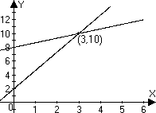 | - 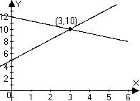
- 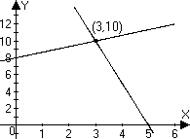 | - 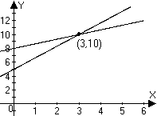

- Which one of the following systems of equations is inconsistent?

- Which one of the following systems of equations is consistent and not dependent?

- Which one of the following systems of equations is independent and consistent?

- Which of the following is not an elementary row operation?
  - Divide a row by 17.
  - Add one row to another row.
  - Interchange the first row with the next row.
  - Interchange the first and second elements of a row.
  - Subtract the second row from the first row.
- Solve the system of equations by using a graph. Give coordinates of the solution.
- A farmer sells two types of avocados: she sells haas avocados for $1.80 each and fuerte avocados for $1.40 each. The farmer earned $36 revenue selling at total of 22 avocadoes during a day. Set up a system of two equations in two unknowns and solve the system to determine how many haas avocados she sold.
- Solve the system by substitution.
- Solve the system by using elimination.
- An auto mechanic charges $427.70 for parts and labor. If the labor cost $32.90 more than the parts, how much does each cost? Use algebra to solve the problem.

- A collection of nuts, bolts and washers contains 40 in all. The nuts weigh 2.5 grams, the bolts weigh 5 grams and the washers weigh 2 grams. The total weight of the collection is 129 grams. There are two more bolts than there are washers. Set up and solve a system of equations to find how many of each type of object there are.

- Solve the system by back substitution:

- Find a solution to the system (in x, y and z) with the augmented matrix:
- Use matrix reduction to solve the system:

- Solve the system using Gaussian elimination on an augmented matrix:
- Use matrix reduction to solve the system:

- The sum of the interior angles in any quadrilateral is . In quadrilateral ABCD, is a , is half the sum of and , and is more than three times . Find the degree measure of each angle.
- Graph the system of inequalities, label the vertices with coordinate values and shade the solution region.
- Consider the problem of optimizing P = 50x + 30y
subject to the constraints:
  - Make a graph illustrating the region where the constraint system is satisfied.
  - Find the coordinates of the vertices for this feasible region.
  - Find the maximum and minimum values of P satisfying the constraints.

- Use a calculator to find exact values for the solution of the system.
- Use a calculator to write the augmented matrix for the system in problem #21 in upper triangular form.

- Use a calculator to solve the system with the augmented matrix.

- Use a calculator to solve the system of equations.
- Use a calculator to find the row echelon form of the augmented matrix associated with problem #24. Write entries either as decimals or fractions.
Solutions For Chapter 2 Test Form B.
- d | - d | - b | - a | - c | - d
- 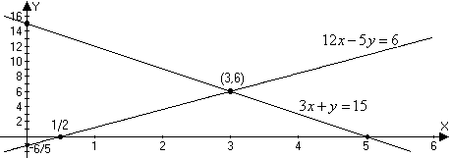
- Let H represent the number of haas avocados sold and let F represent the number of fuerte avocados sold. Then and . Substituting into the first equation we have and thus so that .
- and .
- Eliminating x, we have and
- Let L = the cost of labor, then the cost of the parts is , and the total cost is
and the cost of parts is $197.70.
- Let N = number of nuts, B = number of bolts and W = number of washers. Then
Thus,
- . Thus, .
- So .
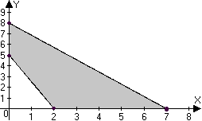
- Let A = the degree measure of , B = the degree measure of , etc.
Then and . Substituting for B, .

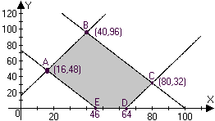
- The maximum value of P is 4960 at (80,32) and the minimum value is 2240 at (16,48).
- Using “SIMULT” on the TI-85, we find and : 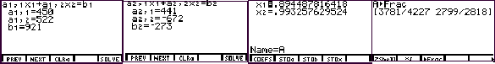
- As the screen shots below show, on the TI-85, you can enter the matrix and store it to A. Then use the “ref” command on A to convert it to row-echelon form. Converting to fractions, we see that the row-echelon form for the augmented matrix is 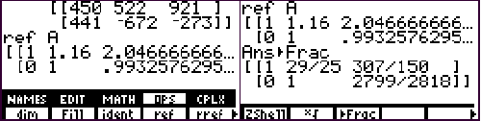

- Using the “rref” command to perform row operations that transform the augmented matrix to reduced row echelon form, we see that : 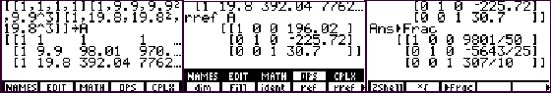
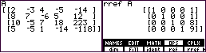
- Again, using “rref” on the augmented matrix can solve the system. Evidently, the solution is :
- Using the “ref” command gives upper triangular form. With one fixed decimal place mode, the TI-85 produces the following decimal result: 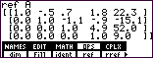
Converting to fractions, we get:
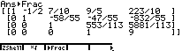 or,

