CHAPTER 2 TEST A Name: ______________________
Directions: Show all work. Section: _____________________

- Which of the following is the solution to the system of equations: ?
- Which graph shows the solution to the system of equations: ?
- 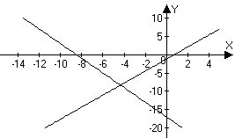 | - 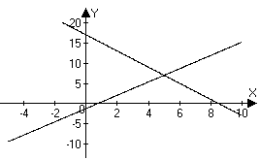
- 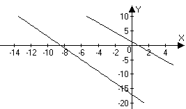 | - 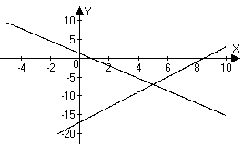

- Which one of the following systems of equations is inconsistent?

- Which one of the following systems of equations is consistent and not dependent?

- Which one of the following systems of equations is dependent?
- Which of the following is not an elementary row operation?
  - Add the first row to the third row.
  - Divide the entries of the second row by 7.
  - Multiply the first row by zero.
  - Interchange the first and last rows.
  - Subtract the second row from the third row.
- Solve the system of equations by using a graph. Give coordinates of the solution.
- A concession stand sold two sizes of lemonade. The large size cost $1.50 and the small size cost $0.85. If the concession stand made $88.80 in revenue selling 80 lemonades during a day, how many large lemonades were sold?
- Solve the system by substitution.
- Solve the system by using elimination.
- Barney charges $65 to wash and wax a compact car. If the wax costs $18 more than the wash, how much does each cost? Use algebra to solve the problem.

- A collection includes nickels, dimes and quarters. There are 24 coins. The total value of the coins $3 and there is one more nickel than there are dimes. Set up and solve a system of equations to find how many of each type of coin there are.

- Solve the system by back substitution:

- Find a solution the system (in x, y and z) with the augmented matrix:
- Use matrix reduction to solve the system:

- Solve the system using Gaussian elimination on an augmented matrix:
- Write a sequence of row equivalent augmented matrices to achieve an upper triangular matrix and then use back substitution to solve the system:

- The sum of the interior angles in any quadrilateral is . In quadrilateral ABCD, is a right angle, is more than the sum of and , and is less than twice . Find the degree measure of each angle.

- Graph the system of inequalities, label the vertices with coordinate values and shade the solution region:
- Consider the problem of optimizing P = 10x + 15y
subject to the constraints:
  - Make a graph illustrating the region where the constraint system is satisfied.
  - Find the coordinates of the vertices for this feasible region.
  - Find the maximum and minimum values of P satisfying the constraints.

- Use a calculator to find exact values for the solution of the system.
- Use a calculator to write the augmented matrix for the system in problem #21 in upper triangular form.

- Use a calculator to solve the system with the augmented matrix.

- Use a calculator to solve the system of equations.
- Use a calculator to find the row echelon form of the augmented matrix associated with problem #24. Write entries either as decimals or fractions.
Solutions For Chapter 2 Test Form A.
- e | - b | - c | - a | - b | - c
- 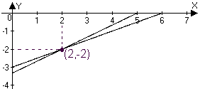
- Let L represent the number of large lemonades sold and let S represent the number of small lemonades sold. Then 150L + 85S = 8880 and L + S = 80. Substituting L=80 - S into the first equation we have 150(80 - S) + 85S = 12000 - 65S = 8880 and thus S = 3120/65 = 48 so that L = 80 – 48 = 32.
- and .
- Eliminating y, we have and
- Let W = the cost of washing, then the cost of waxing is W+18, and the total cost is
and the cost of waxing is $41.50.
- Let N= number of nickels, D= number of dimes and Q= number of quarters. Then
Thus
- . So the sol’n is
- So
- Let A =, B =, etc. Then A=90 and . Also,
- 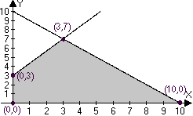
- 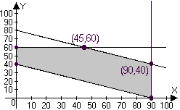
- Using the “SIMULT” program on the TI-85, for instance, 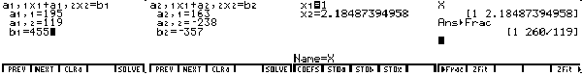

- Starting with “SIMULT”, we can get row echelon form for the augmented matrix 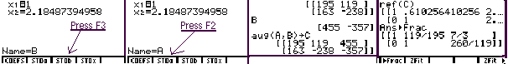

- Using the “rref” command to perform row operations that transform the augmented matrix to reduced row echelon form, we see that : 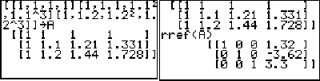
- Again, using “rref” on the augmented matrix can solve the system. Evidently, the solution is : 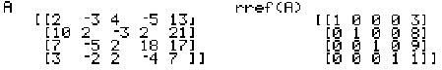
- Using the “ref” command gives upper triangular form: 