CHAPTER 1 TEST C Name: __________________________
Directions: Show all work. Section: _________________________

- A forklift truck rental costs $64 per day plus $26/hour for the operator. Which one of the plots below best describes the total cost, C (in $), in relation to the time, t (in hours), that the forklift truck is operated during a day?
- 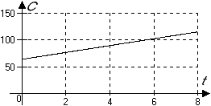 | - 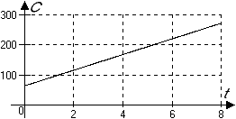
- 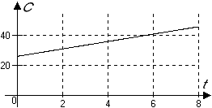 | - 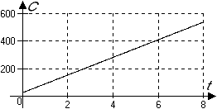
- 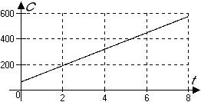 | - 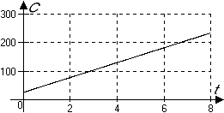

- A ride on the Larkspur ferry costs $3 for adults and $1.50 for children. If the twenty pupils in Mr. Gandola’s fourth grade class have budgeted $100 for ferry rides, which one of the following formula describes how much is left in the ferry budget after the class has taken n ferry rides with their teacher?

- Which table of values describes the intercepts for ?

- Determine whether or not the table represents and in a linear relation.
 | 0 | 3 | 12 | 84 | 144
 | -1 | 0.25 | 4 | 41 | 54

- Which ratio represents the slope of the line segment connecting and ?

- Which of the following equations describes a line passing through the origin and perpendicular to ?

- Write an equation for the line with slope and x-intercept .

- Complete the table of values for the linear equation :
 | 0 |  | 28
 |  | 0

- Is the line passing through and parallel to the line shown in the graph? 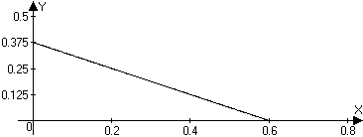

- The depth of water in a bucket (in centimeters) over time (in days) as the water evaporates is tabulated below. Is the depth decreasing at a linear rate? If not, why not? If so, what is the rate of change of the temperature measured in degrees centigrade per minute?
Time (in days) | 0 | 5 | 13 | 21
Depth of water (in centimeters) | 30 | 26.8 | 21.4 | 15.8

- Are the lines given by these equations parallel, perpendicular or neither?
;
- What are the coordinates where the horizontal line crosses ?

- In January of 1985, the population of black-footed ferrets in Wyoming had dwindled to 6. Because of this, the Wyoming Game and Fish Department launched a captive breeding program. By January of 1997, the captive population had grown to about 450. If we assume that the growth rate of the black-footed ferret population in this region is constant, in what year will the population first exceed 1000?
- Graph the equation showing the coordinates of the two intercepts.
- In the two right triangles shown below, which hypotenuse has the steeper slope? Justify your answer.
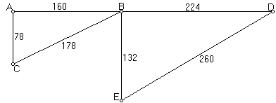

- Garrett sold $115.2 worth of pottery at the flea market. He sold two types of pots: porcelain plates cost $6.30 each and stoneware mugs cost $5.40 each.
  - Write an equation that relates P, the number of porcelain plates he sold to S, the number of stoneware mugs he sold.
  - Find the intercepts and graph this equation in the P-S coordinate system.

- Given that a line has slope and y-intercept , complete the table:
 | 0 | 7 | 14 | 21 | 28

- Find the slope of a line segment parallel to the line segment joining the points and

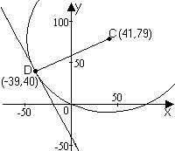
- Find an equation for the line perpendicular to and passing through the midpoint of the line segment joining and .

- The center of a circle is the point C and D is a point on the circle. Find the equation of the line tangent to the circle at the point D. (See the figure at right.)

- Use a calculator to approximate the intercepts of .
- Use a calculator to approximate, to the nearest hundredth, the intercepts of
- Use a calculator to approximate, to the nearest hundredth, the slope of the line given by
- Use a calculator to approximate the slope of the line given by
- Use a calculator to complete the table of approximate values for :
 | -2 | -1 | 0 | 1

Solutions For Chapter 1 Test Form C.
- b | - c | - d | - No. |  | - e | - b
- Yes, they are parallel.
- No, the depth isn’t changing at a constant rate:
- The lines are perpendicular.
- The coordinates of the point of intersection are (4,-3)
- The population t years after 1997 is modeled by . The model predicts when ; that is, that the population will reach 1000 in 2011. | - 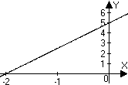
- Since , hypotenuse ED has a steeper slope.
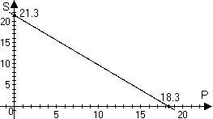
- .
- The slope is . The midpoint is at . So any equation for this line will be equivalent to .
- .
- The intercepts are approximately and .
- The intercepts are approximately and
- The slope is approximately 0.87.
- The slope is approximately 0.98.

