CHAPTER 1 TEST B Name: ______________________
Directions: Show all work. Section: _____________________

- A taxicab in Manhattan costs $2 per ride plus $0.30 for every 1/5 of a mile driven. Which of the plots below best describes the cost of a taxi ride, C (in $), in relation to the distance, d (in miles), of a taxi ride?
- 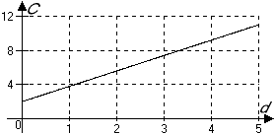 | - 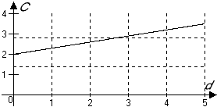
- 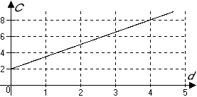 | - 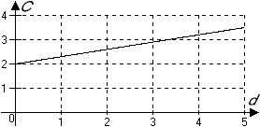
- 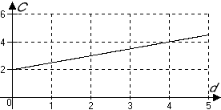 | - 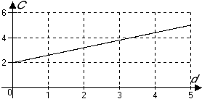

- A subway ride in New York City costs $1.50. If a family of four has budgeted $80 for subway rides, which one of the following formula describes how much money remains in their subway budget after the family has gone on n rides?

- Which table of values describes the intercepts for ?

- Determine whether or not the table represents and in a linear relation.
 | 0 | 1.1 | 11 | 55 | 110
 | 2 | 2.99 | 11 | 47 | 92

- Which ratio represents the slope of the line segment connecting and ?

- Which of the following equations describes a line passing through the origin and perpendicular to ?

- Write an equation for the line with slope and passing through .

- Complete the table of values for the linear equation :
 | 0 |  | 30
 |  | 0

- Is the line passing through and parallel to the line shown in the graph? 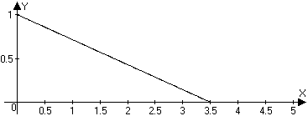

- The weight (in kilograms) over time (in days) of a pumpkin as it grows over a month is tabulated below. Is the weight increasing at a linear rate? If not, why not? If so, what is the rate of change of the weight measured in kilograms per day?
Time (in days) | 0 | 10 | 17 | 26 | 31
Weight (kilograms) | 2.3 | 4.3 | 5.7 | 7.5 | 8.5

- Are the lines given by the equations below parallel, perpendicular or neither?
;
- What are the coordinates where the vertical line crosses ?

- In December of 1995, 35 gray wolves from Canada were released on remote Forest Service lands in Idaho. All of the reintroduced wolves were fitted with radio collars and monitored by biologists from the Fish and Wildlife Service. The reintroduction has been very successful and by December 1997 about 80 wolves lived in the area. If we assume that the growth rate of the gray wolf population in this region will be constant, in what year will the population first exceed 1000?
- Graph the equation showing the coordinates of the two intercepts.
- In the two rectangles shown below, which diagonal has a steeper slope, or are the slopes equal in magnitude? Justify your answer.
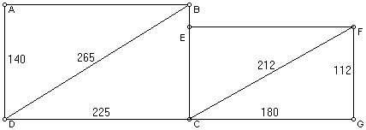

- Genevieve sold $105.20 worth of beaded necklaces through her web page. She sold two types of necklaces: the peacock ensemble cost $5.95 each and the southwestern snakeskin costs $6.95 each.
  - Write an equation that relates P, the number of peacock ensembles she sold to S, the number of southwestern snakeskins she sold.
  - Find the intercepts and graph this equation in the P-S coordinate system.

- Given that a line has slope and x-intercept , complete the table:
 | -28 | -21 | -14 | -7 | 0

- Find the slope of a line segment parallel to the line segment joining the points and

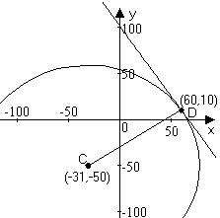
- Find an equation for the line perpendicular to and passing through the midpoint of the line segment joining and .

- The center of a circle is the point C and the point D is on the circumference of the circle. Find the equation of the line tangent to the circle at the point D. (See the figure at right.)

- Use a calculator to approximate to the nearest hundredth the intercepts of
- Use a calculator to approximate to the nearest hundredth the intercepts of
- Use a calculator to approximate to the nearest hundredth the slope of the line given by
- Use a calculator to approximate the slope of the line given by
- Use a calculator to complete the table of approximate values for :
 | 0 | 1 | 2

Solutions For Chapter 1 Test Form B.
- c | - c | - a | - No. |  | - b | - c
- Yes, they are parallel.
- Yes, the weight is increasing at a constant rate of 0.2 kilograms per day.
- The lines are neither parallel nor perpendicular.
- The coordinates of the point of intersection are (-5,1)
- The population t years after 1995 is modeled by . when . The model predicts the population will reach 1000 in 2038.
- 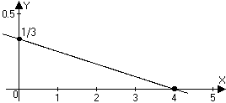
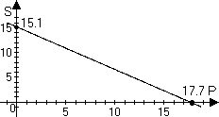
- Since , the slopes of the diagonals are equal in magnitude.
- .
- The slope is . The midpoint is .
So an equation for this line will be equivalent to .
- The intercepts are approximately and .
- The intercepts are approximately and .
- The slope is approximately .
- The slope is approximately –1.50.

