CHAPTER 1 TEST A Name:____ ______________________
Directions: Show all work. Section: _________________________

- A bicycle messenger is paid $80 per day plus $13.33 for every hour she bicycles. Which of the plots below best describes her earnings, E (in $), in relation to the time, t (in hours), that she bicycles during a day?
- 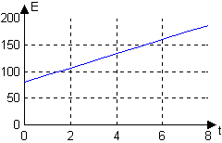 | - 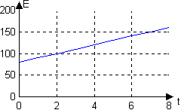
- 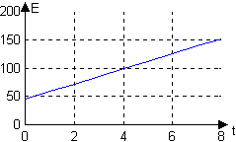 | - 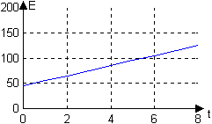
- 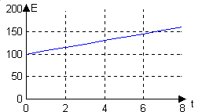 | - 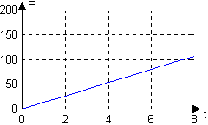

- Jim went to the fair with $50. Tickets for the rides at the fair cost $8 for a book of 12 tickets. Each ride at the fair costs 3 tickets. Which formula describes how much money Jim has after going on n rides?

- Which table of values describes the intercepts for ?

- Determine whether or not the table represents and in a linear relation.
 | 0 | 1 | 10 | 100 | 1000
 | 1 | 1.1 | 2 | 11 | 101

- Which ratio represents the slope of the line segment connecting and ?

- Which of the following equations describes a line passing through the origin and perpendicular to ?

- Write an equation for the line with slope and y-intercept .

- Complete the table of values for the linear equation :
 | 0 |  | 20
 |  | 0

- Is the line passing through and parallel to the line shown in the graph? 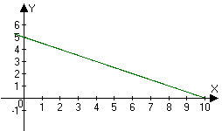

- The temperature (degrees centigrade) over time (minutes) of a potato as it cools from a temperature of centigrade is tabulated below. Is the temperature decreasing at a linear rate? If not, why not? If so, what is the rate of change of the temperature measured in degrees centigrade per minute?
Time (in minutes) | 0 | 3 | 9
Temperature (degrees centigrade) | 100 | 80.2 | 40.6

- Are the lines given by these equations parallel, perpendicular or neither?
;
- What are the coordinates where the vertical line crosses ?

- The International Marine Mammal Association estimated the Canadian harp seal population to be about 4.8 million seals in January, 1994. The total allowable catch (TAC) for harp seals is 250,000. If we assume that no new harp seals are born and 250,000 are killed every year since 1994, in what year would the harp seal population become extinct?
- Graph the equation showing the coordinates of the two intercepts.
- In the two right triangles shown below, which hypotenuse has a slope with greater absolute value? Justify your answer.
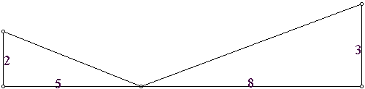

- Susanna sold $49 worth of shells at her seaside stand. She sold two types of shells:
Conch shells cost $2 each and shellacked sand dollars cost $0.50 each.
  - Write an equation that relates the number of conch shells, A, she sold and the number of shellacked sand dollars, B, she sold.
  - Find the intercepts and graph this equation in the A-B coordinate system.

- Given that a line has slope and y-intercept , complete the table:
 | 0 | 3 | 9 | 27

- Find the slope of a line segment parallel to the line segment joining the points and

- Find an equation for the line perpendicular to and passing through the midpoint of the line segment joining and .
- The center of a circle is the point C and D is a point on the circle. Find the equation of the line tangent to the circle at the point D. (See the figure at right.) | 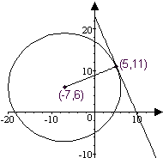

- Use a calculator to approximate the intercepts of
- Use a calculator to approximate the intercepts of
- Use a calculator to approximate the slope of the line given by
- Use a calculator to approximate the slope of the line given by
- Use a calculator to complete the table of approximate values for :
 | 0 | 1 | 2

Solutions For Chapter 1 Test Form A.
- a | - e | - c | - Yes. |  | - c | - d
- Yes, they are parallel.
- Yes, the temperature is decreasing at a rate of 6.6 degrees Celsius per minute.
- The lines are parallel.
- The coordinates of the point of intersection are (2,1)
- The population t years after 1994 is . This population is zero when . So the population will be extinct in 2013.
- 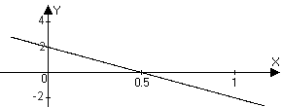
- Since , the triangle with legs 2 and 5 has a steeper slope.
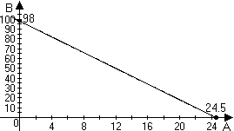
- The slope is . The midpoint is .
So an equation for this line will be equivalent to .
- The intercepts are approximately and .
- The intercepts are approximately and
- The slope is approximately 0.707.
- The slope is approximately –1.58

